**A Project Report on**

|  |  |
| --- | --- |
|  | **Semester-IV**  **2024**  **ITCC14**  **IT Project** |
|  |  |

**SHOPPERSTACK**

Submitted as partial fulfillment of the requirement

For M.Sc**. IT - Semester IV**

Prepared for Subject: **IT Project** (**ITCC14**)

**Prepared By**

**Name of Student : Gaurav Zalavadiya**

**Samir Kotharia**

**Enrollment No.: 22MSCIT22015**

**22MSCIT22016**

**Exam No.:**



Shri Maneklal M. Patel Institute of Sciences and Research**,**

**Kadi Sarva Vishwavidyalaya**

**M.Sc. (IT), Gandhinagar.**

Shri Maneklal M. Patel Institute of Sciences and Research**,**



**Kadi Sarva Vishwavidyalaya, M.Sc. (IT) Gandhinagar.**

Date:

**IT Project CERTIFICATE**

This is to certify that the project report submitted by ***Gaurav Zalavadiya, Kotharia Samir*,** having enrollment no. **22MSCIT2215, 22MSCIT22016**, a student of **M.Sc. IT Semester- IV,** has completed his/her project titled “***Shopper stack”*** satisfactorily during the academic year 2023-24.

We appreciate the enthusiasm & dedication towards work submitted.

**Prof. (Dr)** **B. R. Pandya**

Head of Department, M.Sc. IT

**Internal Project Guide**

Mr. /Ms. **Name of Guide**

Asst. Professor

M.Sc. (IT) Department.



**ACKNOWLEDGMENT**

I am grateful to my internal guide ***Dr.Bhavesh Kataria*** for providing me valuable guidance for the **IT PROJECT** (ITCC14) and other domain related information.

I would like to express my endless thanks to ***Shivu D. Shetty***, for giving invaluable advice, direction, support and transferring knowledge throughout the project work.

Also my hearty gratitude to Head of Department, **Prof. (Dr.) B. R. Pandya** for giving me an opportunity for learning through the process of project work by which I can improve my technical skills along with practical exposure and its applicability in the industry.

**Name of Student: Signature of Student:**

**Gaurav Zalavadiya**

**Kotharia Samir**

Enrollment No.:

**22MSCIT22015**

**22MSCIT22016**

**INDEX**

|  |  |  |
| --- | --- | --- |
| **Sr no.** | **Topic** | **Page no.** |
| 1. | Introduction | 6 |
| 2. | Scope | 7 |
| 3. | Functional Requirement | 8 |
| 4. | System Architecture, Tools & Tech. | 10 |
| 5. | Requirement | 12 |
| 6. | Functionality Testing | 19 |
| 7. | Integration Testing | 26 |
| 8. | System Testing | 34 |
| 9. | Performance Testing | 35 |
| 10. | Test case | 43 |
| 11. | Defect Report |  |
| 12. | AI Automation Testing | 53 |
| 13. | Future Enhancement | 62 |

**INTRODUCTION**

Welcome to Shopperstack, where convenience meets quality!

At Shopperstack, we pride ourselves on offering a seamless online shopping experience tailored to meet your needs. Whether you're searching for the latest fashion trends, cutting-edge gadgets, or everyday essentials, we've got you covered.

Browse through our extensive collection of products handpicked from top brands and trusted sellers. From fashion-forward apparel to state-of-the-art electronics, home essentials to fitness gear, we have something for everyone.

With our user-friendly interface and secure payment options, shopping with us is not just easy but also safe and reliable. Plus, our dedicated customer support team is always here to assist you every step of the way, ensuring your satisfaction is our top priority.

Join the millions of satisfied customers who have made Shopperstack their go-to destination for all their shopping needs. Start exploring now and experience the ultimate convenience of online shopping with us!

**SCOPE**

The scope of an e-commerce website refers to the range and extent of features, functionalities, and services that the website aims to offer to its users. Here's a breakdown of the typical scope of an e-commerce website:

1. Product Catalog Management
2. User Registration and Authentication
3. Browsing and Search Functionality
4. Shopping Cart
5. Checkout Process
6. Payment Gateway Integration
7. Order Management
8. Customer Support and Communication
9. Security Features
10. Scalability and Performance
11. Integration with Other Systems

**FUNCTIONAL REQUIREMENT**

Functional requirements for Shopperstack website outline the specific features and functionalities that the website must have in order to meet the needs of users and achieve its business objectives. Here are some essential functional requirements for an e-commerce website:

1. User Registration and Authentication: Users should be able to create accounts, log in securely, and manage their profiles, including addresses, payment methods, and order history.
2. Product Catalog Management: The website should allow administrators to add, edit, and delete product listings, including details such as title, description, images, pricing, and inventory levels.
3. Browsing and Search Functionality: Users should be able to easily browse through products using categories, filters, and sorting options, as well as search for specific products using keywords.
4. Product Details Pages: Each product should have its own dedicated page displaying detailed information, including images, descriptions, specifications, pricing, availability, and related products.
5. Shopping Cart: Users should be able to add items to their shopping carts, view cart contents, update quantities, remove items, and proceed to checkout seamlessly.
6. Checkout Process: A smooth and intuitive checkout process is essential, including multiple payment options, shipping methods, billing and shipping address entry, order summary, and order confirmation.
7. Order Management: Administrative tools for managing orders, including order processing, order status updates, order fulfillment, shipping tracking, and communication with customers regarding order status.
8. Responsive Design: The website should be optimized for various devices and screen sizes, ensuring a seamless user experience across desktops, tablets, and smartphones.
9. Inventory Management: Tools for managing product inventory, including real-time updates on stock levels, inventory tracking, low stock alerts, and automated inventory replenishment.

**SYSTEM ARCHITECTURE, TOOLS & TECHNOLOGY**

There are main 3 modules in Shopperstack :

1. Admin
2. User
3. Merchant

Technology & Tools :

1. Window 10/11
2. Operating System x32/x64

Require Software :

1) For Automation Scripting :

- Eclipse IDE

1. For AI Automation Scripting :

- Fireflink

**REQUIREMENT**

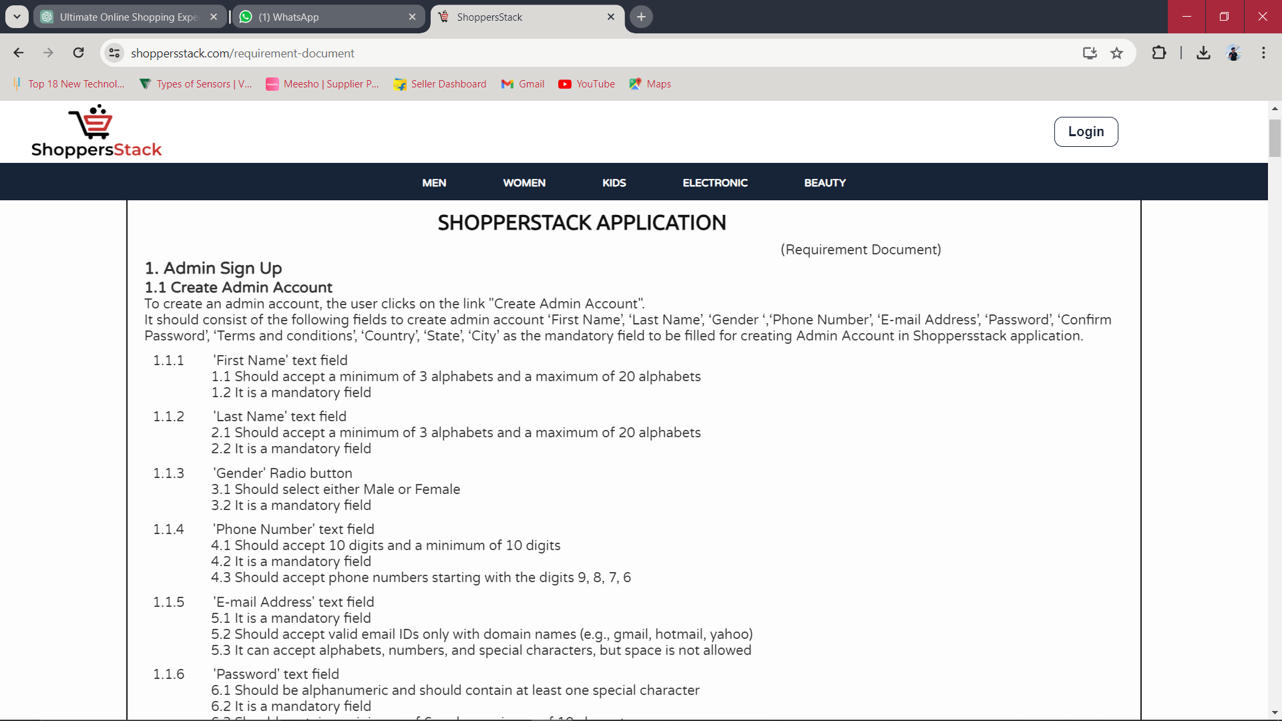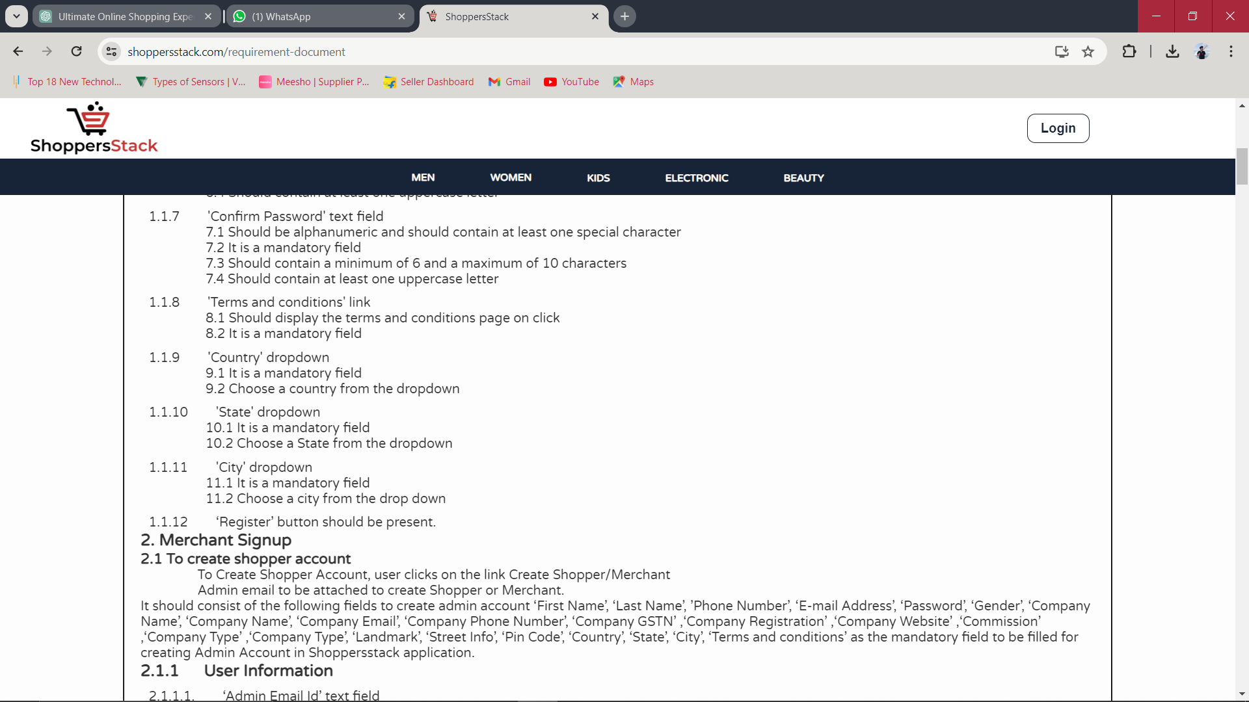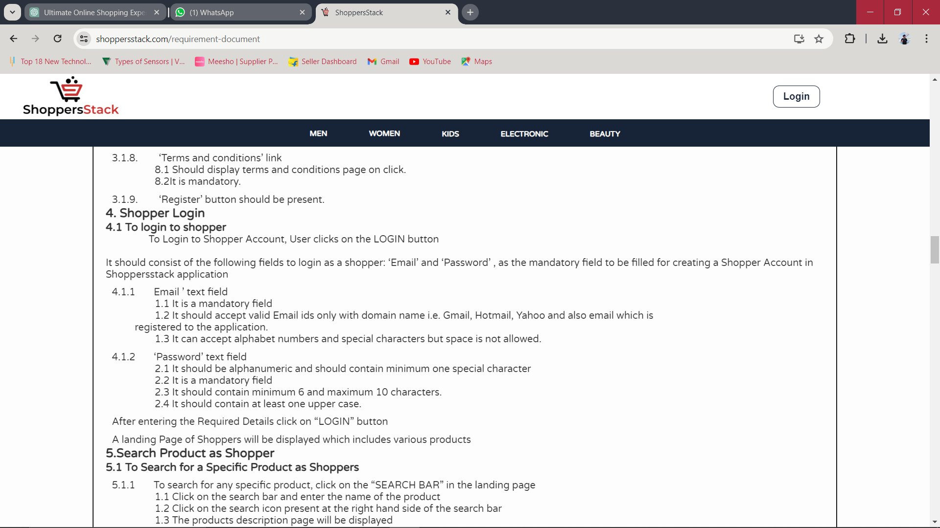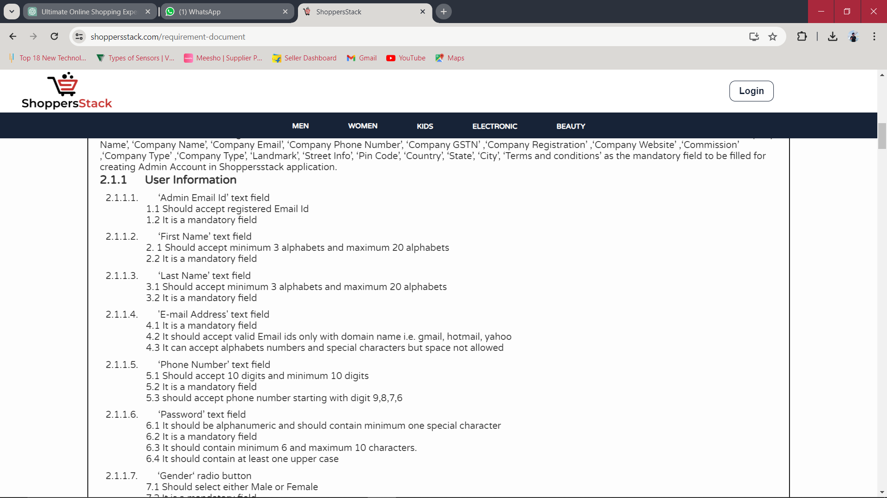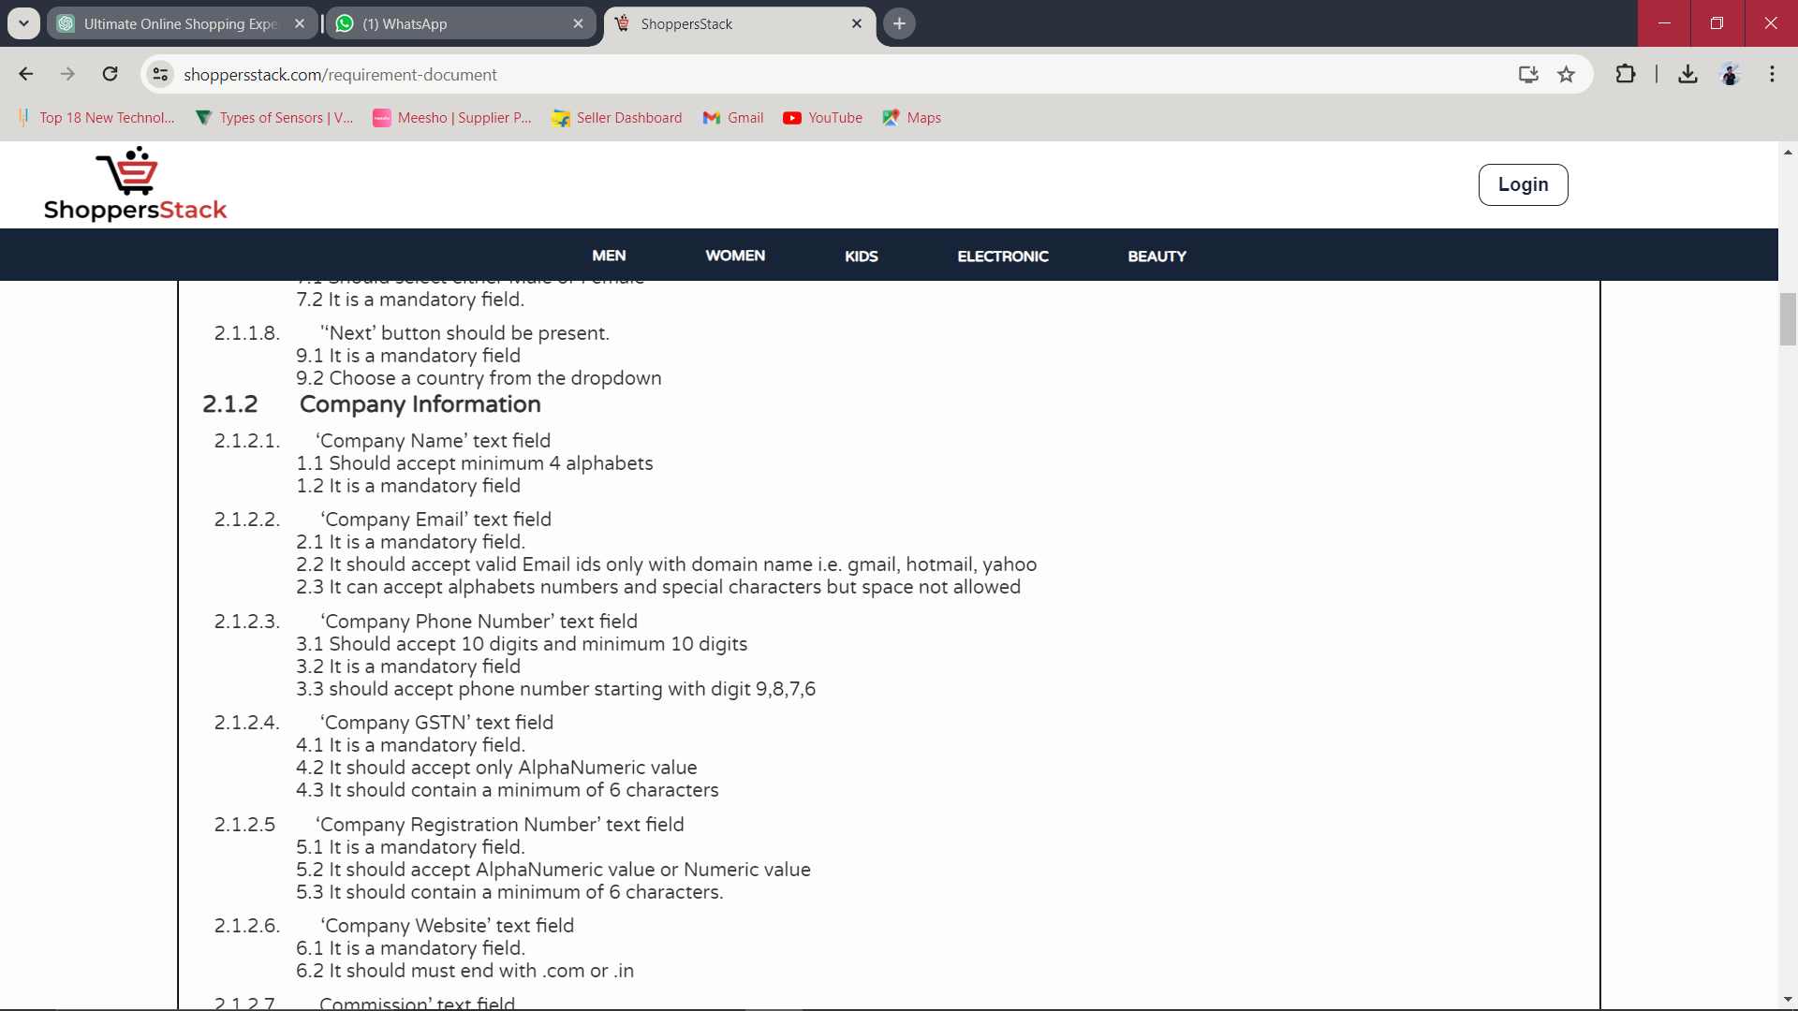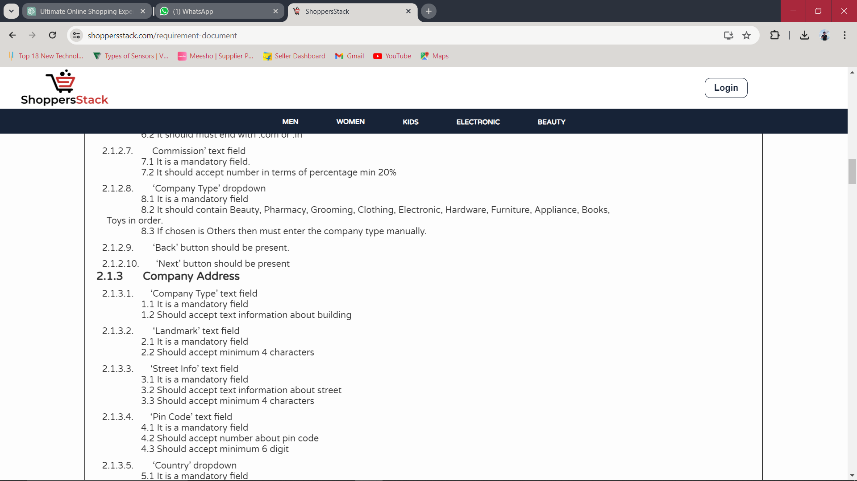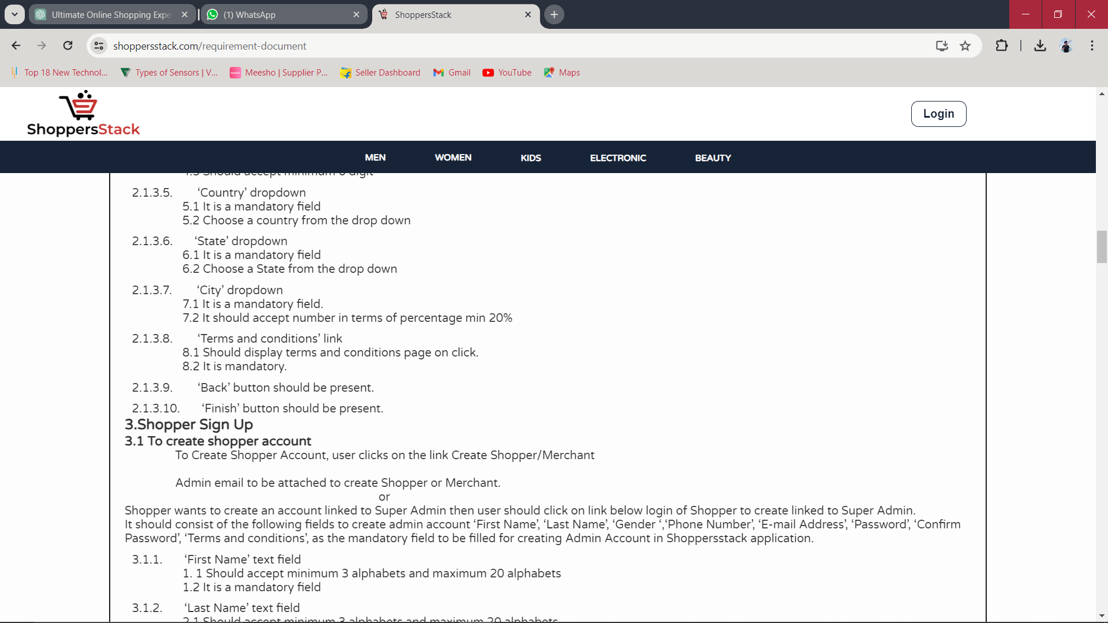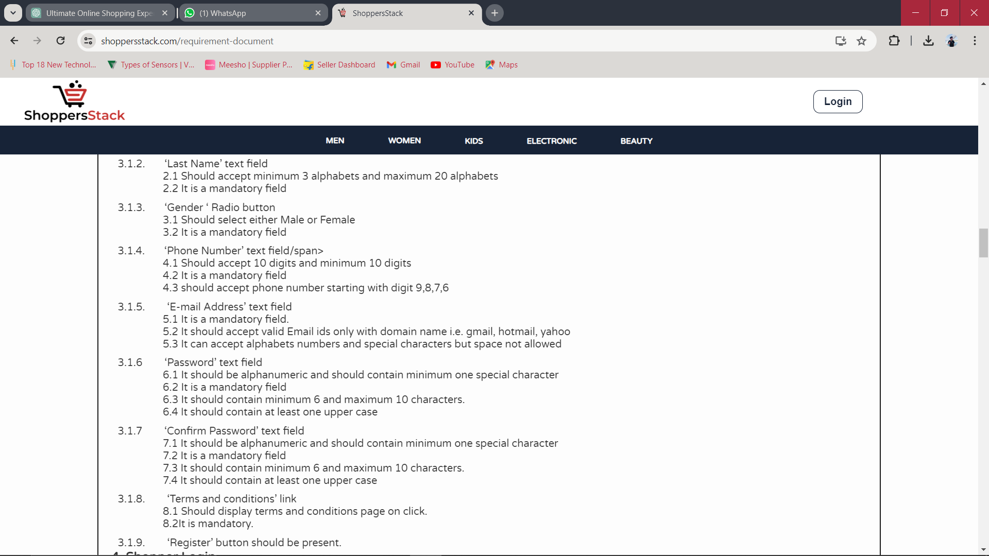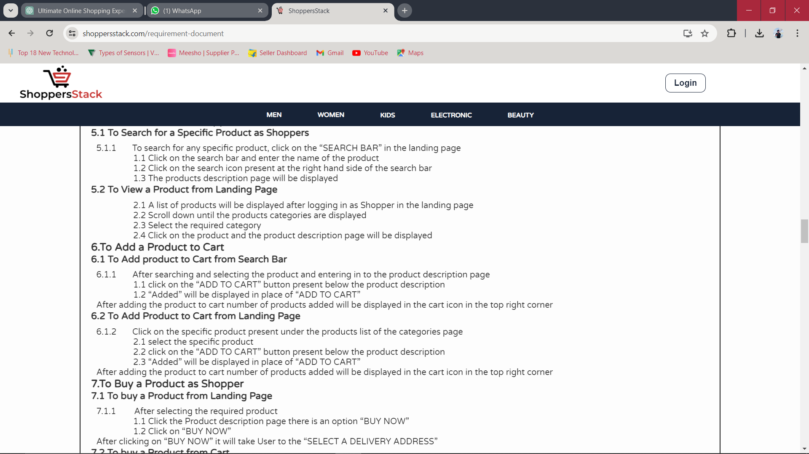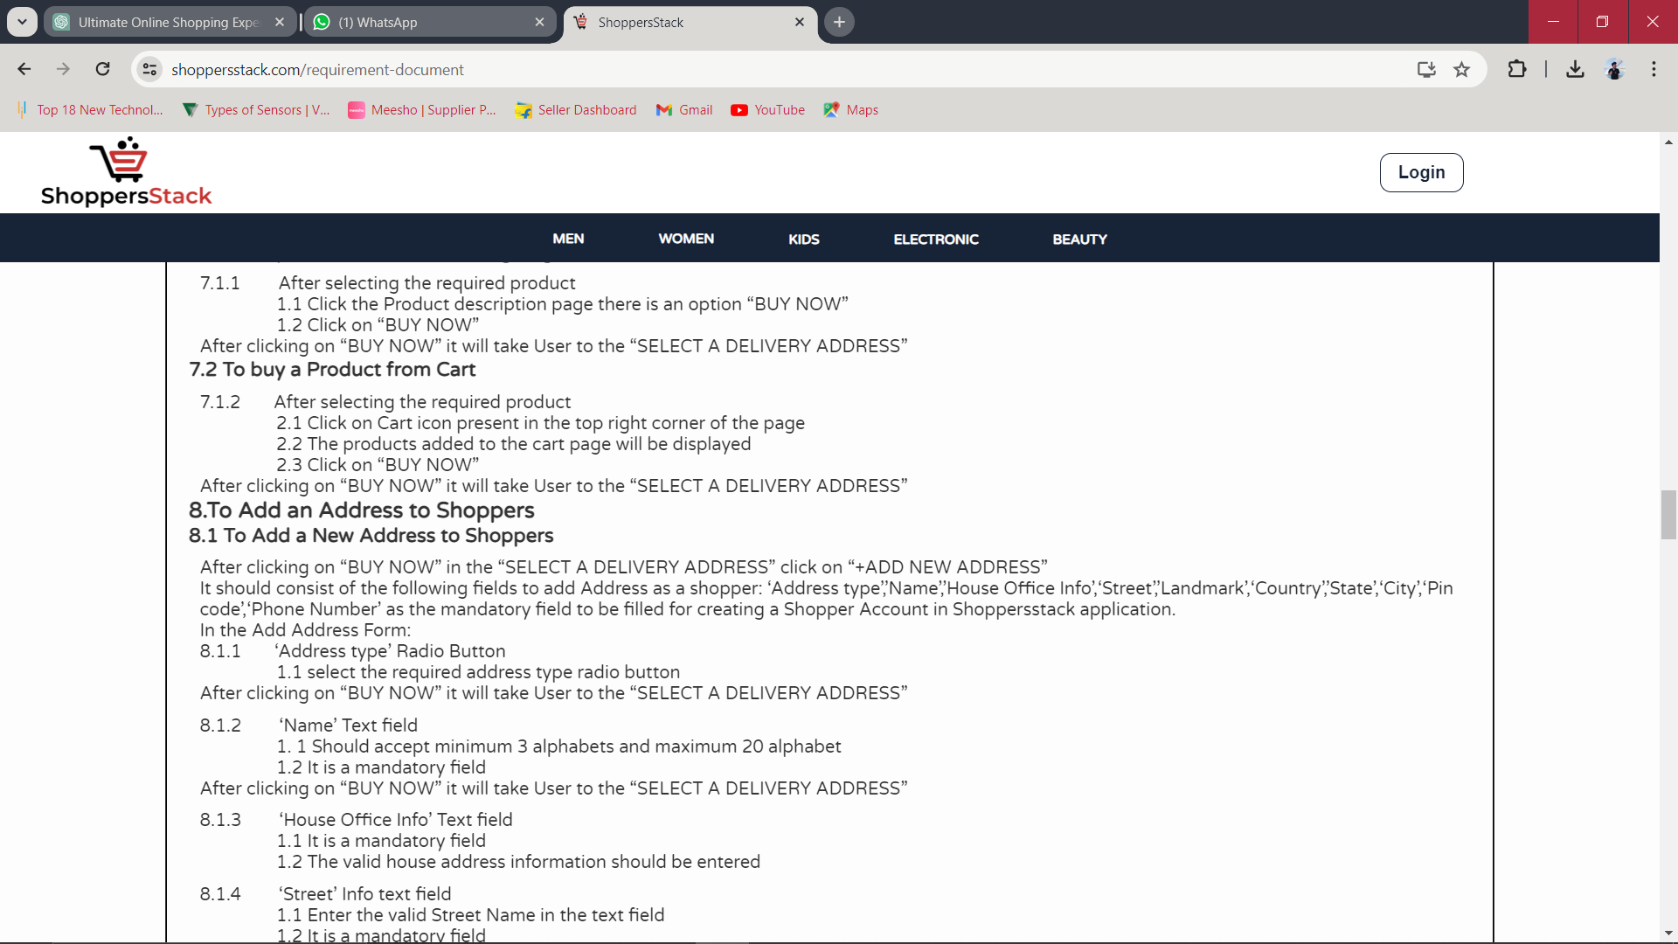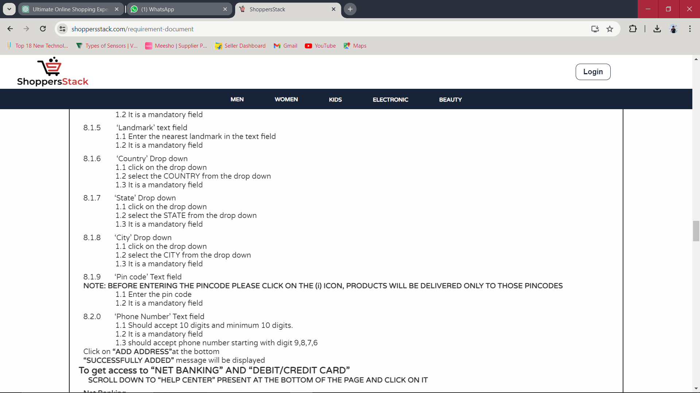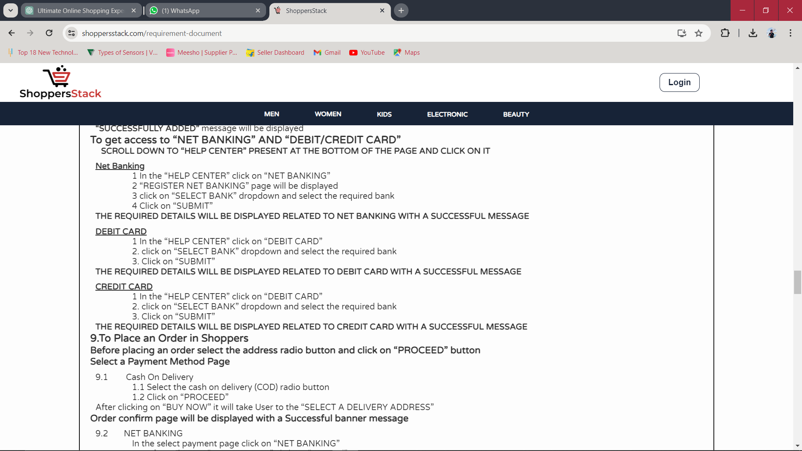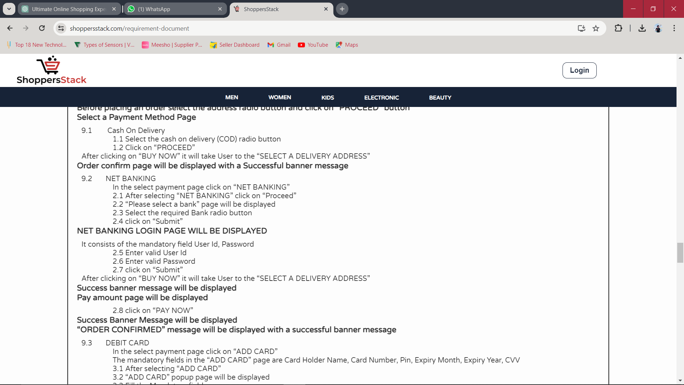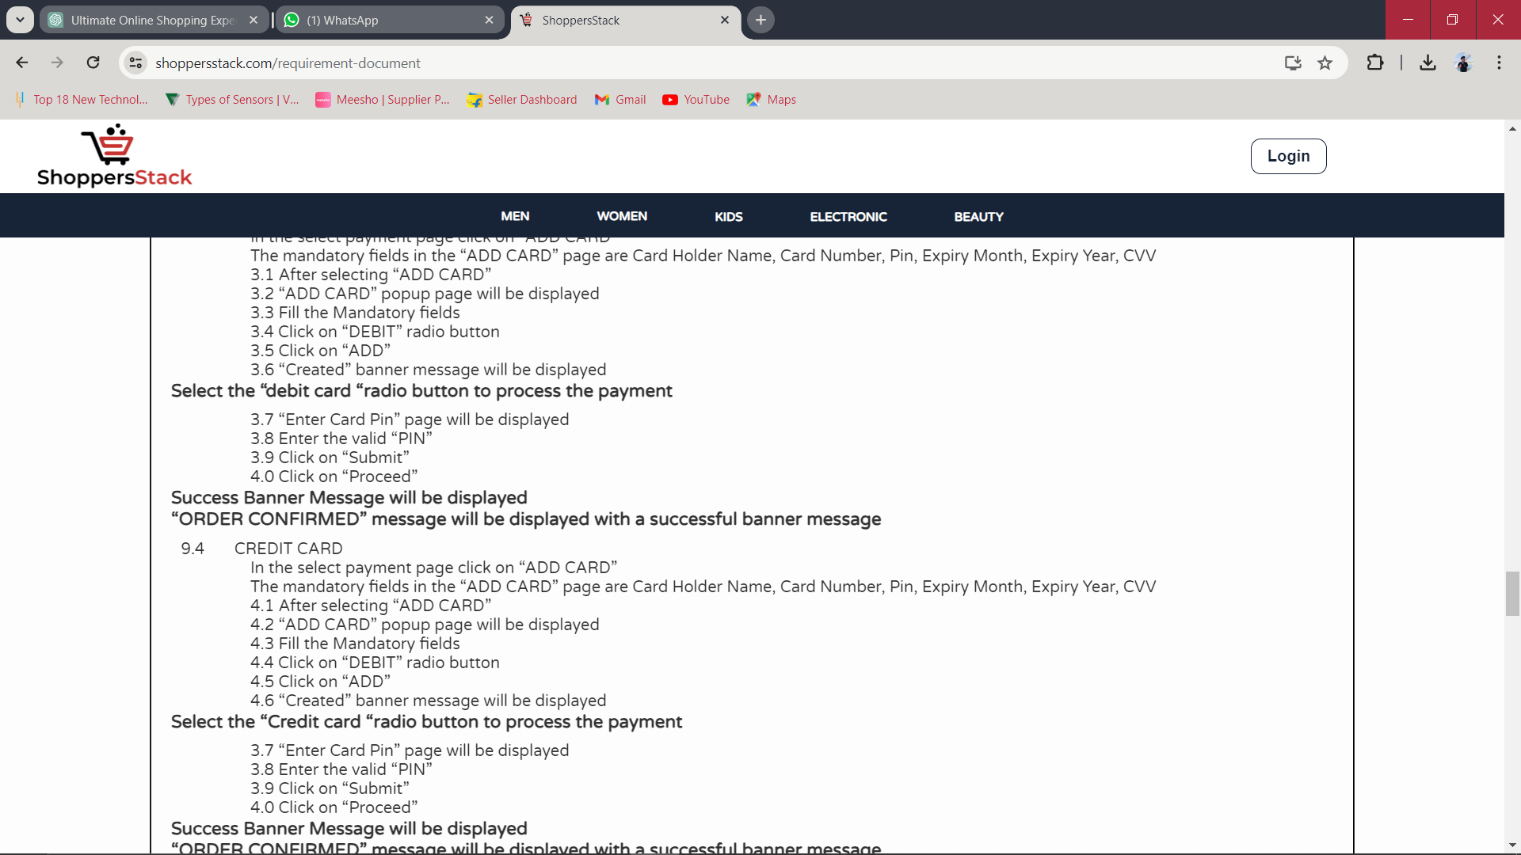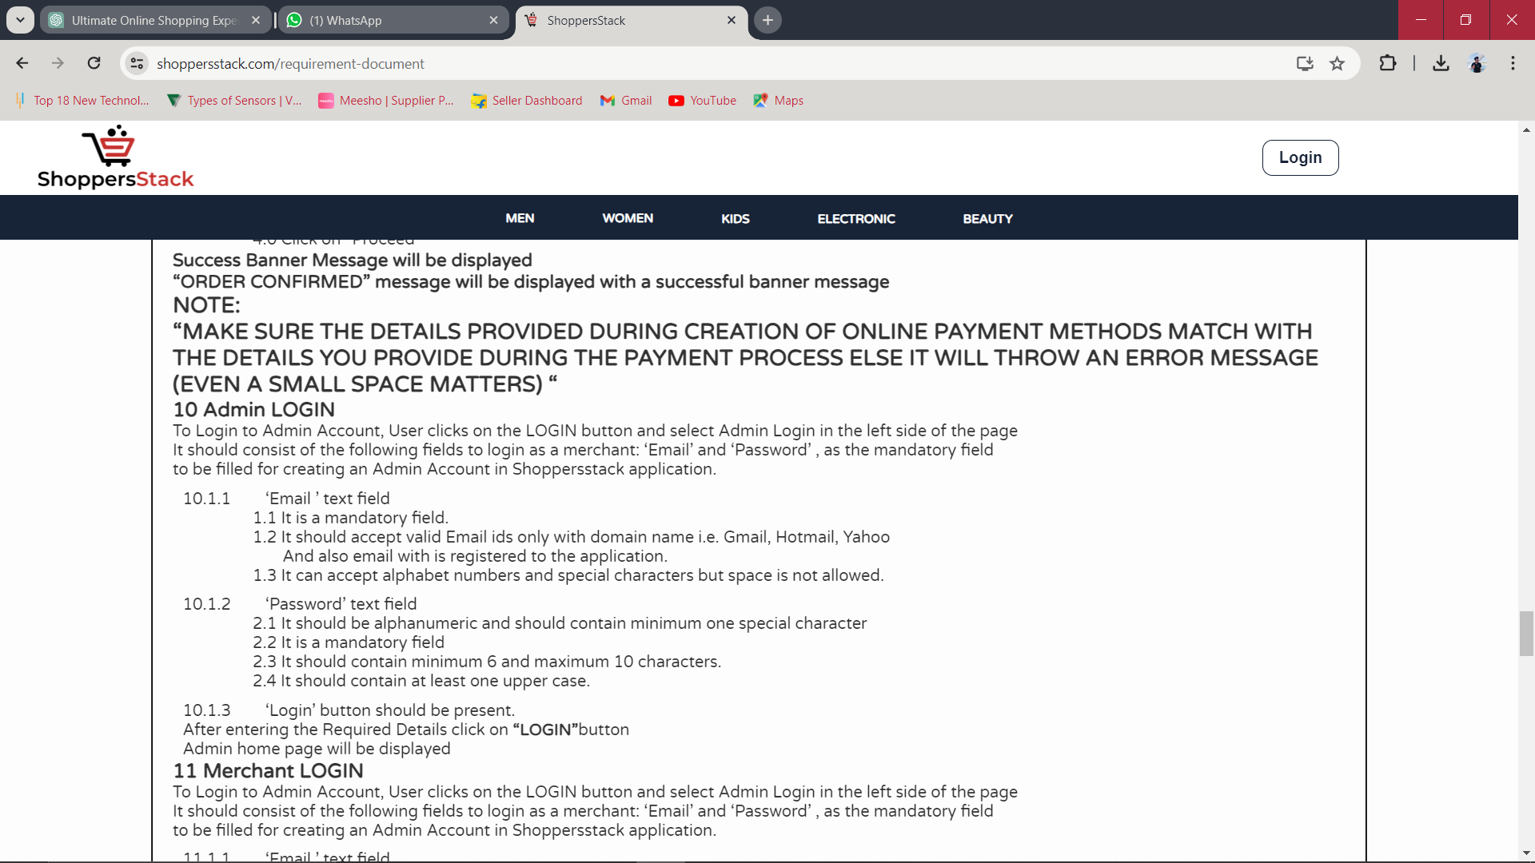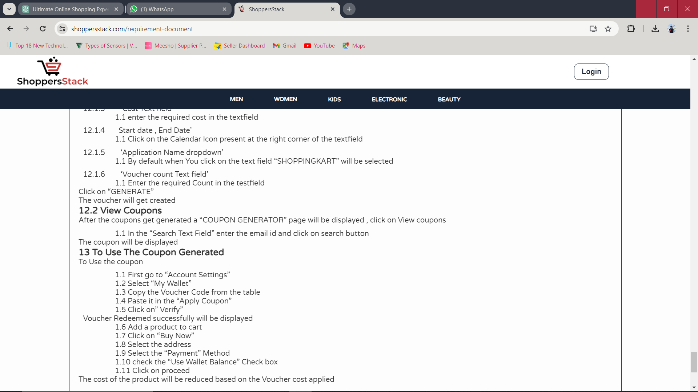

**FUNCTIONALITY TESTING**

Testing each and every component or feature of an application thoroughly in detail, against customer requirement specification is called as Functionality Testing.

1.Login Page:

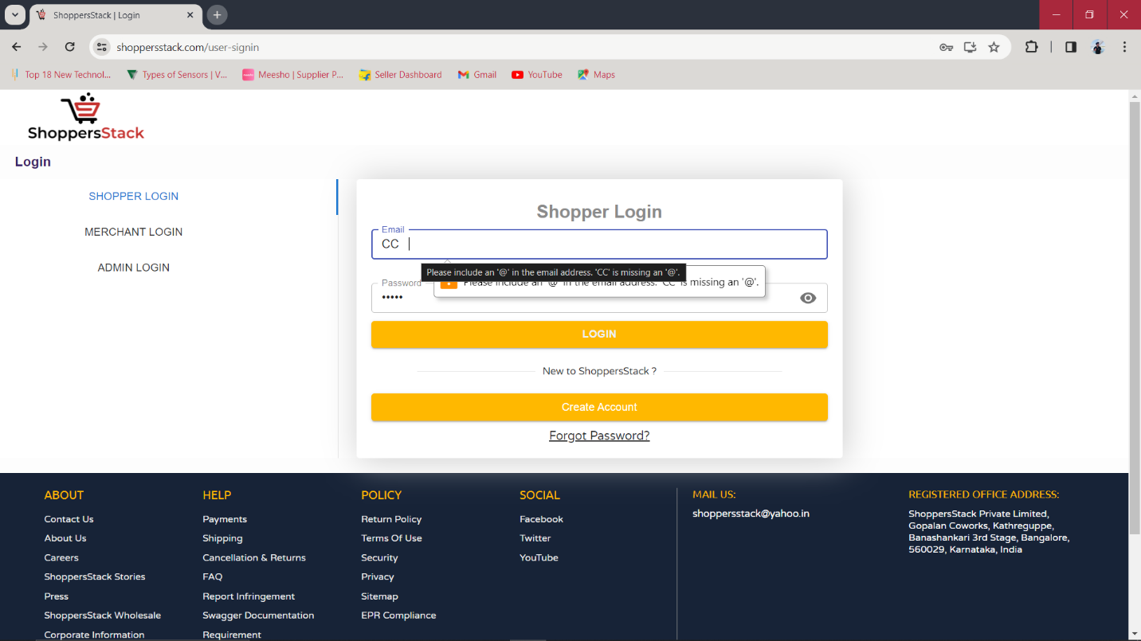

Email Text Field:

* To check that or verify that Email ID Text field Should accept only alphameric characters.
* To check that or verify that Email ID Text field Should not accept special characters.
* To check that or verify that Email ID Text field Should accept special characters only ‘@’ and ‘_’.
* To check that or verify that Email ID Text field Should accept the mail ID ends with email format like ‘abc@gmail.com’, ‘Abc@yahoo.com’,’ABC@hotmail.com’.
* To check that or verify that Email ID Text field Should not accept empty or null value.
* To check that or verify that Email ID Text field Should not accept duplicate or repeated mail Id.
* To check that or verify that Email ID Text field Should be visible or appear in login page.
* To check that or verify that Email ID Text Field should be display validation or suggestion if, user enter an invalid email ID.

Password Test Field:

* To check that or verify that Password Text Field should accept only alphanumeric character and special character.
* To check that or verify that Password Text Field should accept more than 6 characters
* To check that or verify that Password Text Field should not accept null or empty value.
* To check that or verify that Password Text Field should accept only alphanumeric character and special character.
* To check that or verify that Password Text Field should be visible or appear in login page.
* To check that or verify that Password Text Field should accept one or more uppercase letters, lowercase letter and one or more special character.
* To check that or verify that Password Text Field should be display validation or suggestion if, user enter an invalid password.
* To check that or verify that Password Text Field should be maximum length of characters.
* To check that or verify that Password Text Field should hide the password character, if user clicks on Hide option.
* To check that or verify that Password Text Field should show the password character, if user clicks on Show option.
* To check that or verify that Password Text Field, Hide and Show button should be workable or not.

Login Button:

* To check that or verify that Login button should be visible or appear in the login page.
* To check that or verify that Login button should be redirect to home page, if user enter all valid inputs.
* To check that or verify that Login button should be displays an appropriate error message, if user enter an invalid input.

1. Registration Page:

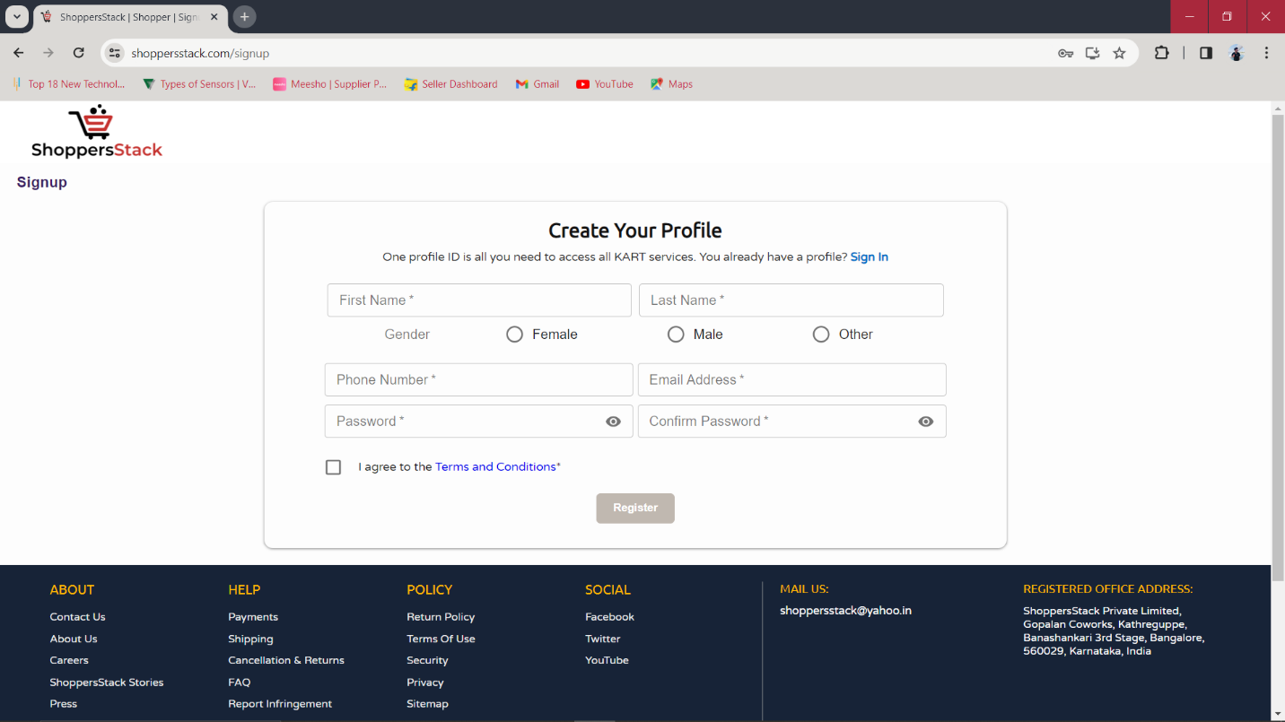

First Name Text Field:

* To check that or verify that First Name Text field Should accept only alphabets.
* To check that or verify that First Name Text field Should not accept special character.
* To check that or verify that First Name Text field Should not accept numbers.
* To check that or verify that First Name Text field Should not accept only one character.
* To check that or verify that First Name Text field Should accept more than one characters.
* To check that or verify that First name Text field Should accept character according to specified length.
* To check that or verify that First Name Text field Should be visible in registration page.
* To check that or verify that First Name Text field Should not accept special character.
* To check that or verify that First Name Text field Should be display validation, if user enter wrong input.

Last Name Text Field:

* To check that or verify that Last Name Text field Should accept only alphabets.
* To check that or verify that Last Name Text field Should not accept special character.
* To check that or verify that Last Name Text field Should not accept numbers.
* To check that or verify that Last Name Text field Should not accept only one character.
* To check that or verify that Last Name Text field Should accept more than one characters.
* To check that or verify that Last Name Text field Should accept character according to specified length.
* To check that or verify that Last Name Text field Should be visible in registration page.
* To check that or verify that Last Name Text field Should not accept special character.
* To check that or verify that Last Name Text field Should be display validation, if user enter wrong input.

Gender Radio Button Field:

* To check that or verify that Gender Radio Button Field Should accept only one select option.
* To check that or verify that Gender Radio Button Field Should not accept input, if user select more than one option.
* To check that or verify that Gender Radio Button Field Should be clickable only one option at a time.
* To check that or verify that Gender Radio Button Field Should be visible in registration page.
* To check that or verify that Gender Radio Button Field Should be display validation, if user enter not select any option.

Phone Number Text Field:

* To check that or verify that Phone Number Text Field Should accept only numbers.
* To check that or verify that Phone Number Text Field Should accept only integer numbers.
* To check that or verify that Phone Number Text Field Should not accept special characters.
* To check that or verify that Phone Number Text Field Should not accept alphabets.
* To check that or verify that Phone Number Text Field Should not accept more than 10 numbers.
* To check that or verify that Phone Number Text Field Should not accept less than 0 numbers.
* To check that or verify that Phone Number Text Field Should not accept floating value.
* To check that or verify that Phone Number Text Field Should be visible in registration page.
* To check that or verify that Phone Number Text Field Should be display validation, if user enter wrong input.

Register Button:

* To check that or verify that Register button should be visible or appear in the registration page.
* To check that or verify that Register button should be redirect to home page, if user enter all valid inputs.
* To check that or verify that Register button should be displays an appropriate error message, if user enter an invalid input.

Scenario:

|  |  |  |
| --- | --- | --- |
| Component | Input/Scenario/Cases | Expected Result |
| Username | ADBCD  abcde  Abc  Aa@12 | A  A  R  R |
| Password | A1@1A  A1A1A1  A@#16  B@C | A  R  A  R |
| Gender | User select Male  User select Female  User Select Other  Select both option  Not select any option | A  A  A  R  R |
| Phone no. | 12 12 12 12 12  8849485558  +91 8849485558  0000.509991.5  A987654321  8849#12654  7875642101 | R  A  R  R  R  R  A |

**INTEGRATION TESTING**

Testing the data flow between the modules is called as Integration Testing.

1. Men Menu:

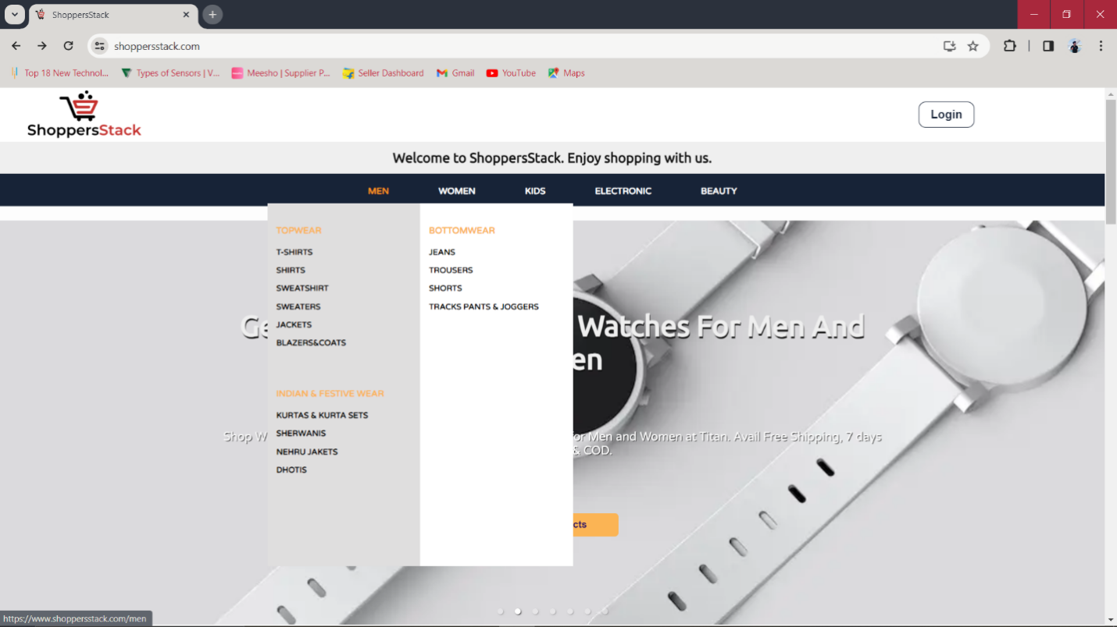

Bottom-Up approch

Top-Down approch

Top-Down approch

Bottom-Up approch

Top-Down approch

Bottom-Up approch

If user want to buy T-shirt or others top wear :

* Log as username and password.
* Select ‘men’ menu.
* In ‘men’ menu select ‘Top wear’.
* In a ‘Top wear’ menu select T-shirt or particular items.

2.Women Menu:

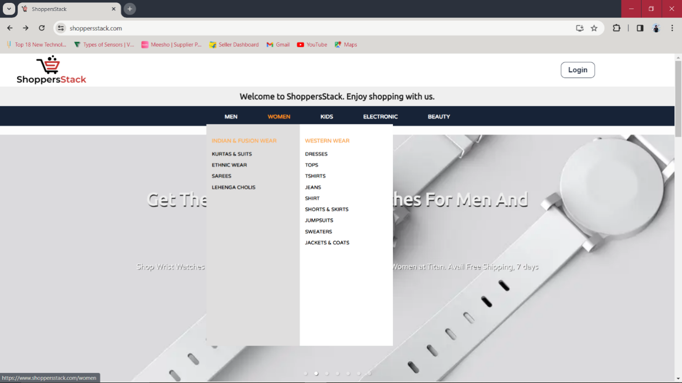

Bottom-Up approch

Top-Down approch

If user want to buy sarees or others Indian wear:

* Log as username and password.
* Select ‘women’ menu.
* In ‘men’ menu select ‘Indian & Fusion Wear’.
* In a ‘Indian & Fusion wear’ menu select Sarees or particular items.

Bottom-Up approch

Top-Down approch

If user want to buy Jeans or others Western wear:

* Log as username and password.
* Select ‘women’ menu.
* In ‘men’ menu select ‘Western wear’.
* In a ‘Western wear’ menu select Jeans or particular items.

3. Kids Menu:

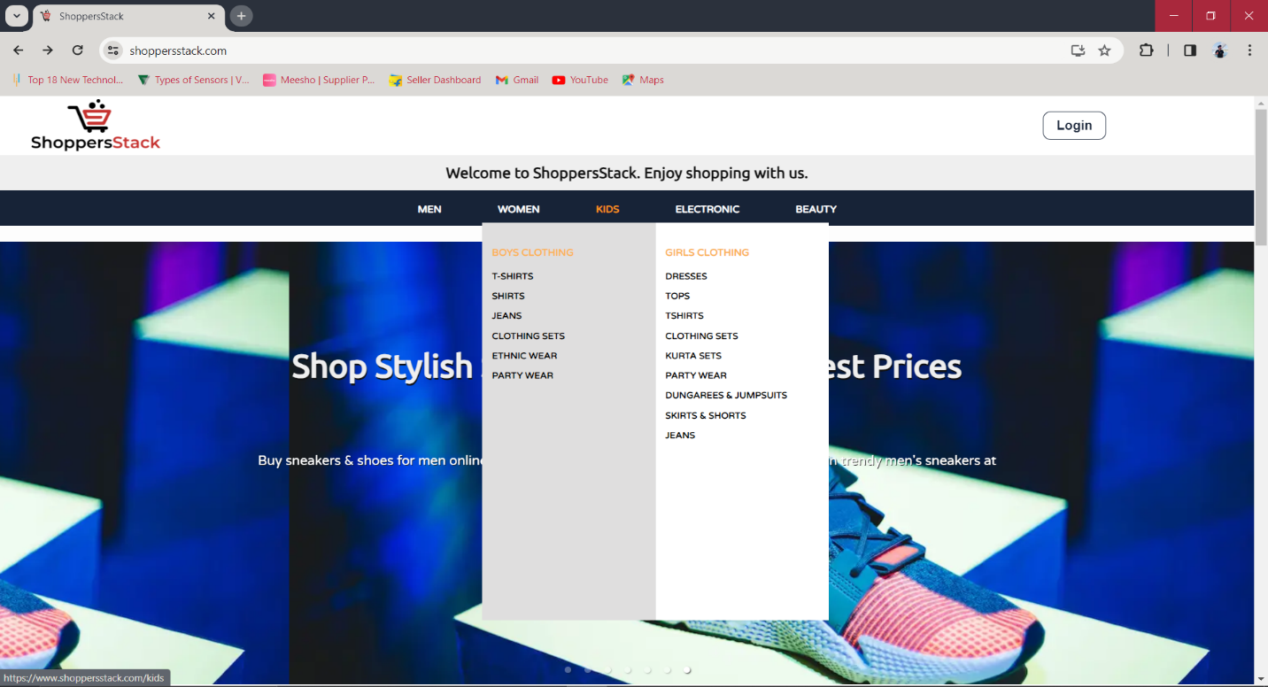

Bottom-Up approch

Top-Down approch

Top-Down approch

Bottom-Up approch

If user want to buy child girl t-shirt:

* Log as username and password.
* Select ‘kids’ menu.
* In ‘kids’ menu selects ‘Girls Clothing’.
* In a ‘Girls Clothing’ menu select t-shirt.

If user want to buy children cloths:

* Log as username and password.
* Select ‘kids’ menu.
* In ‘kids’ menu selects ‘Girls Clothing’ or ‘Boys Clothing’.

4. Electronic Menu:

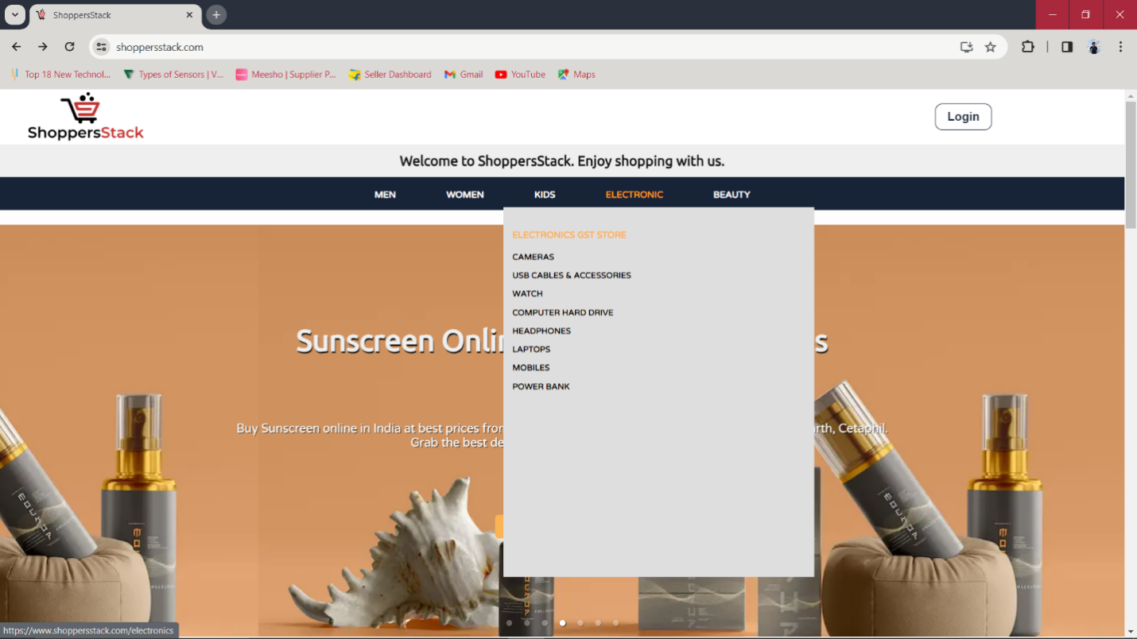

Bottom-Up approch

Top-Down approch

If user want to buy Mobile:

* Log as username and password.
* Select ‘Electronic’ menu.
* In ‘Electronic’ menu select ‘Electronic GST Store’.
* In a ‘Electronic GST Store’ menu select mobiles.

If user want to buy any electronics items:

* Log as username and password.
* Select ‘Electronic’ menu.
* In ‘Electronic’ menu select ‘Electronic GST Store’.

5. Beauty Menu:

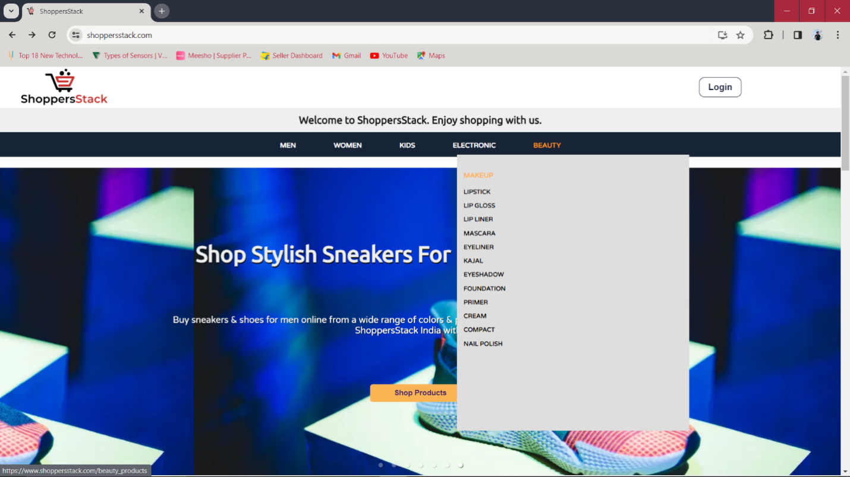

Bottom-Up approch

Top-Down approch

If user want to buy any beauty items:

* Log as username and password.
* Select ‘Beauty’ menu.
* In ‘Beauty’ menu select ‘makeup’.

If user want to buy cream or other beauty items:

* Log as username and password.
* Select ‘Beauty’ menu.
* In ‘Beauty’ menu select ‘makeup’.
* In ‘makeup’ menu select ‘cream’ or other beauty items.

**SYSTEM TESTING**

It is end to end testing where in test Environment is just similar to production environment.

* End to end testing: -

Navigating through all the features and make sure that end features or last feature is working or not is called as end to end testing.

NOTE:

* Whenever we are doing end to end testing, we are not bothered about Functionality testing and integration testing.

Below figure is Showing the System Testing:

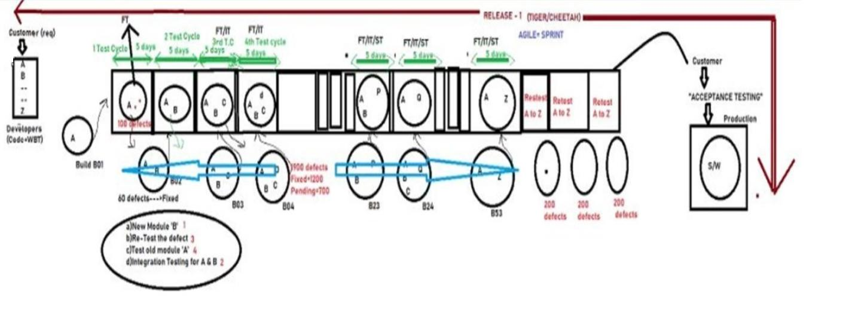

**PERFORMANCE TESTING**

It is also known as Bottle neck testing, Spikelike testing or Baseline testing.

Testing the stability and response time of an application by applying load, is called as performance testing.

Response time: -

Total time taken to receive the request, Execute the program and send the response is called response time.

Performance Testing Tools: -

1. JMeter
2. Neo-load
3. Load-Runner

* How to do performance testing using performance testing with tools.
* Take performance testing tool (JMeter), Write a Script.
* Click on run it will ask how many users and click on run.
* Request are fired to server, now there is a heavy load on server.
* Server send the response to performance testing tool.
* Tool analyze the response and gives the result and in form of flow chart, Table, and Graph.
* Check whether the test is pass or fail.
* If test if fail send it to developer, developer will alter the code to improve the performance this is called performance tuning.
* Once again test engineer should run the script.
* Repeat all the Steps.

**Below Are Some Step-by-Step Images for Performing Performance Testing with JMETER Tool.**

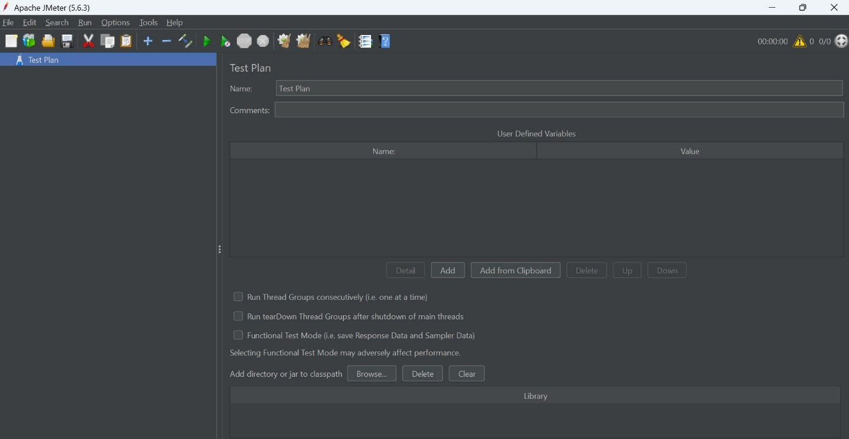

Here, we add the name of the test plan.

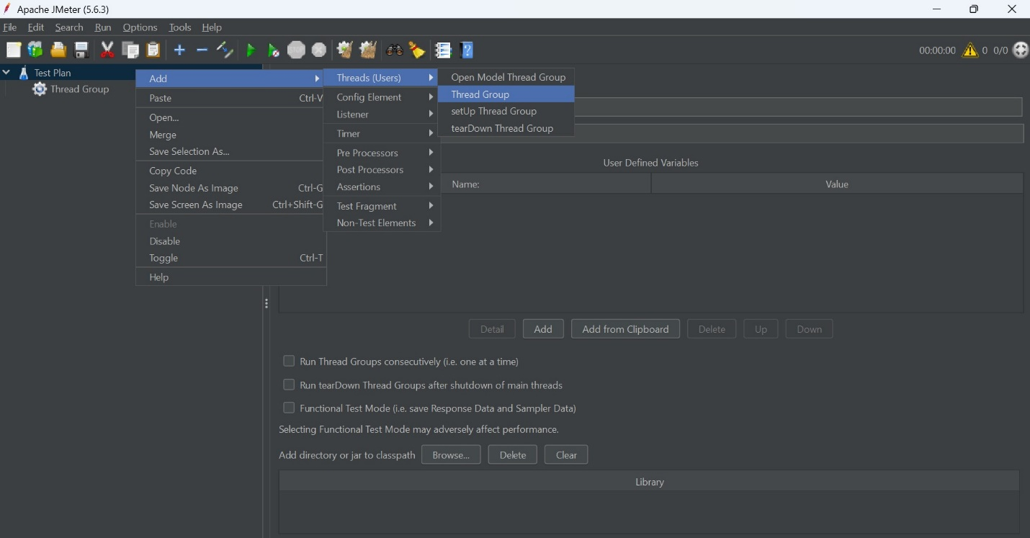

Here we add the Thread Group where we enter the details for performing no. of threads/Users accessing the application, with time.

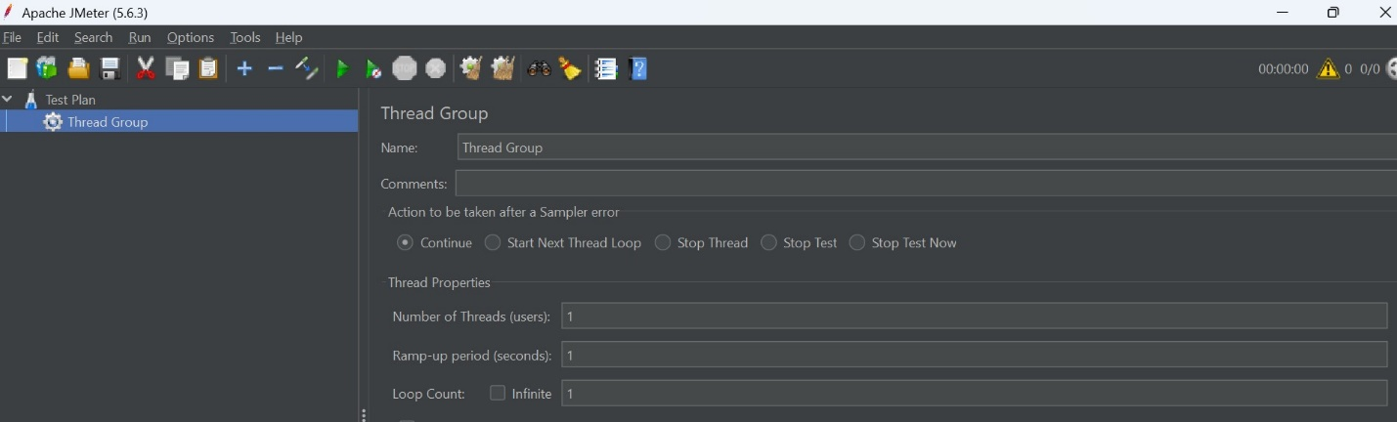

After Setting up the Thread Group, we add the Sampler where we can select HTTP Request.

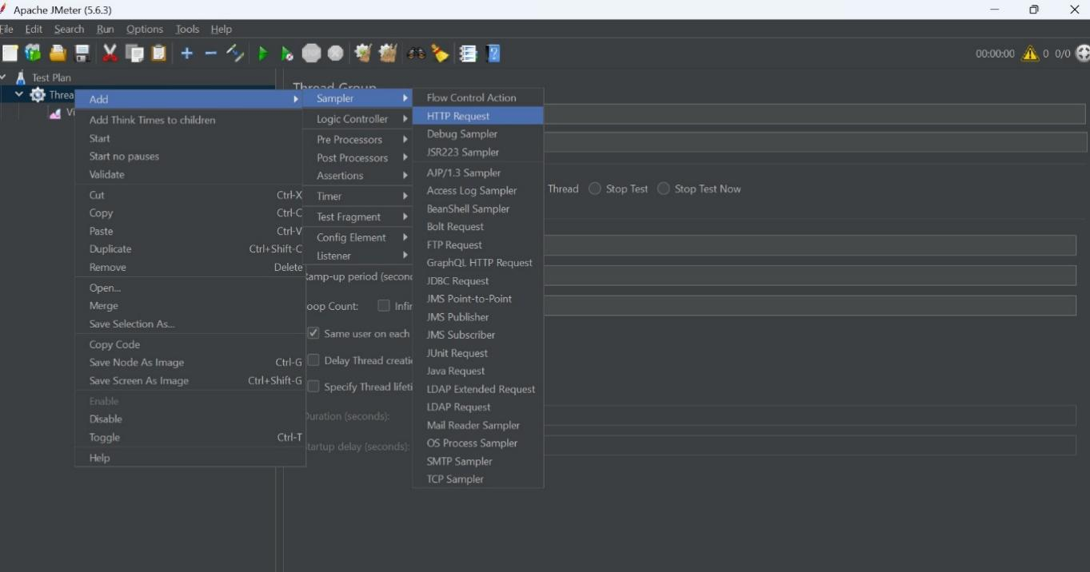

In HTTP Request we can enter Server ID or IP And we can add the Path, as shown in Figure...

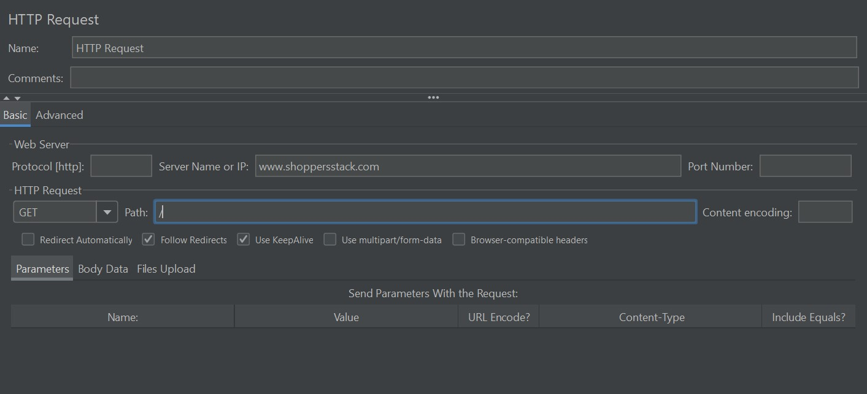

After Setting up the HTTP Request, we add the Listener where we can select in which form, we want testing result.

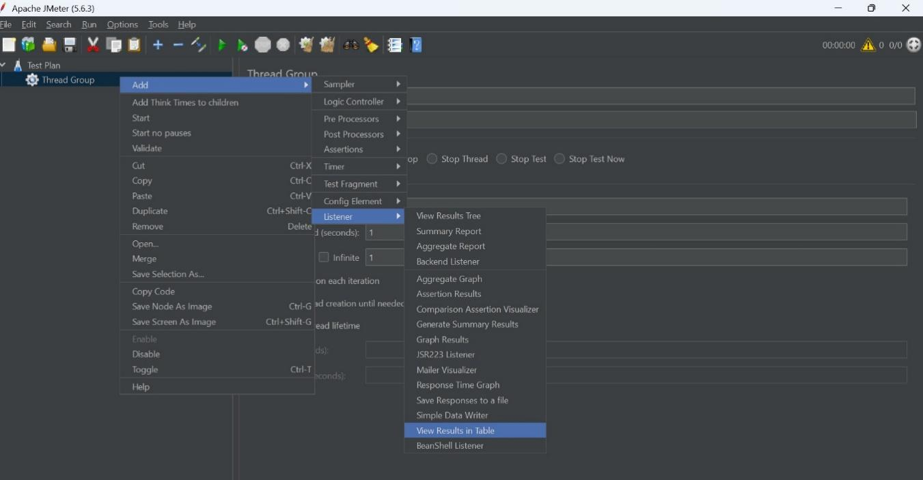

After adding the listener, we run the test and its gives result in the form of table which we select in listener.

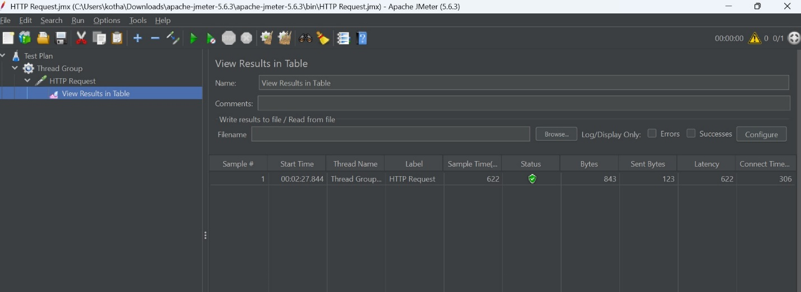

It’s a result with 1 user only and its pass, in status its shows green than the test is pass, if its shows red than fail. Its shows Average time, Latency, Bytes size, Connection time as shown in Image. It depends on the number of users are enter.

Here, it’s a failure test result: -

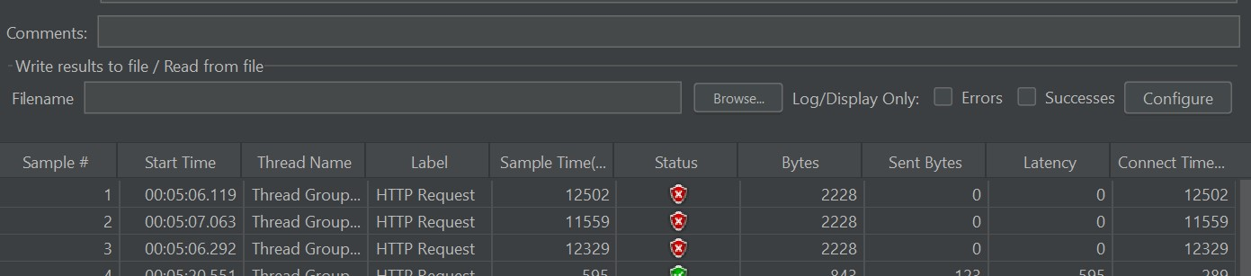

After completing the testing of one path, then we repeat the steps and we have to just change the path as we see in the image:

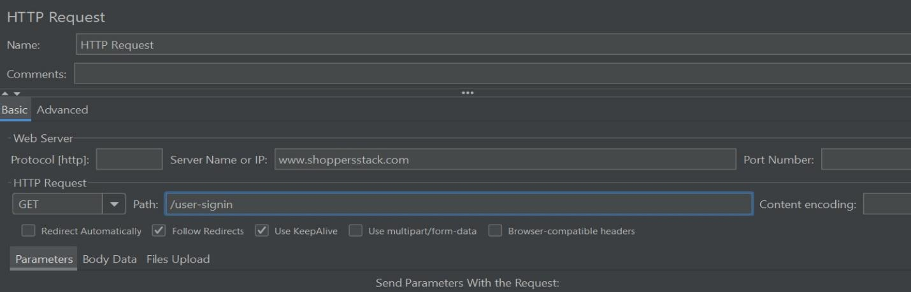

If we increase the Number the users than it gives result like as shown in image:

It’s for passing result.

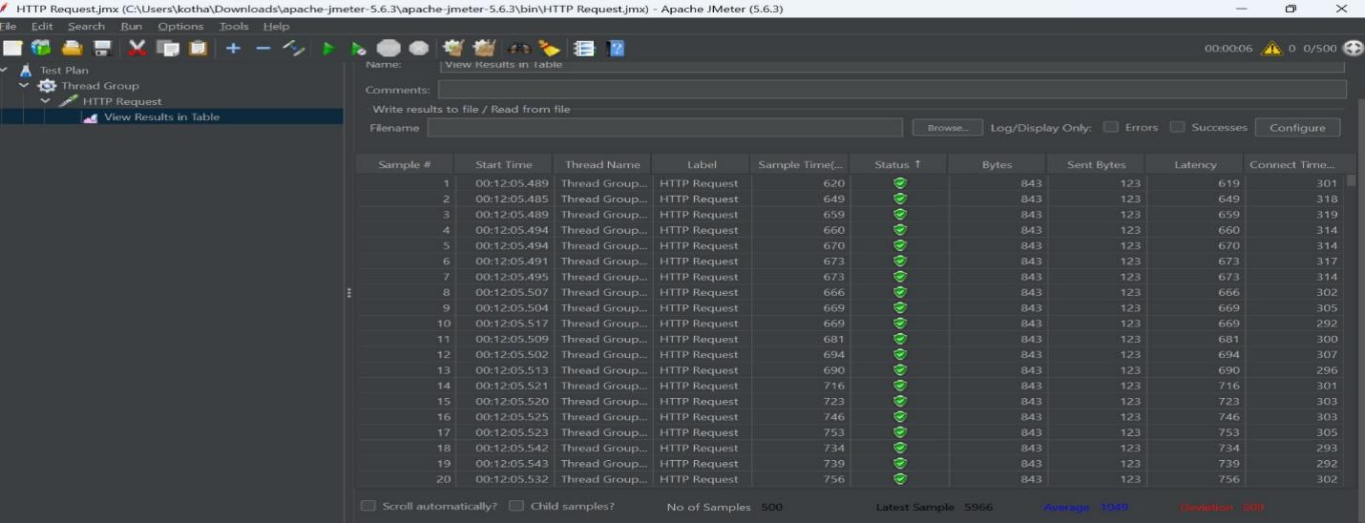

For Failure result:

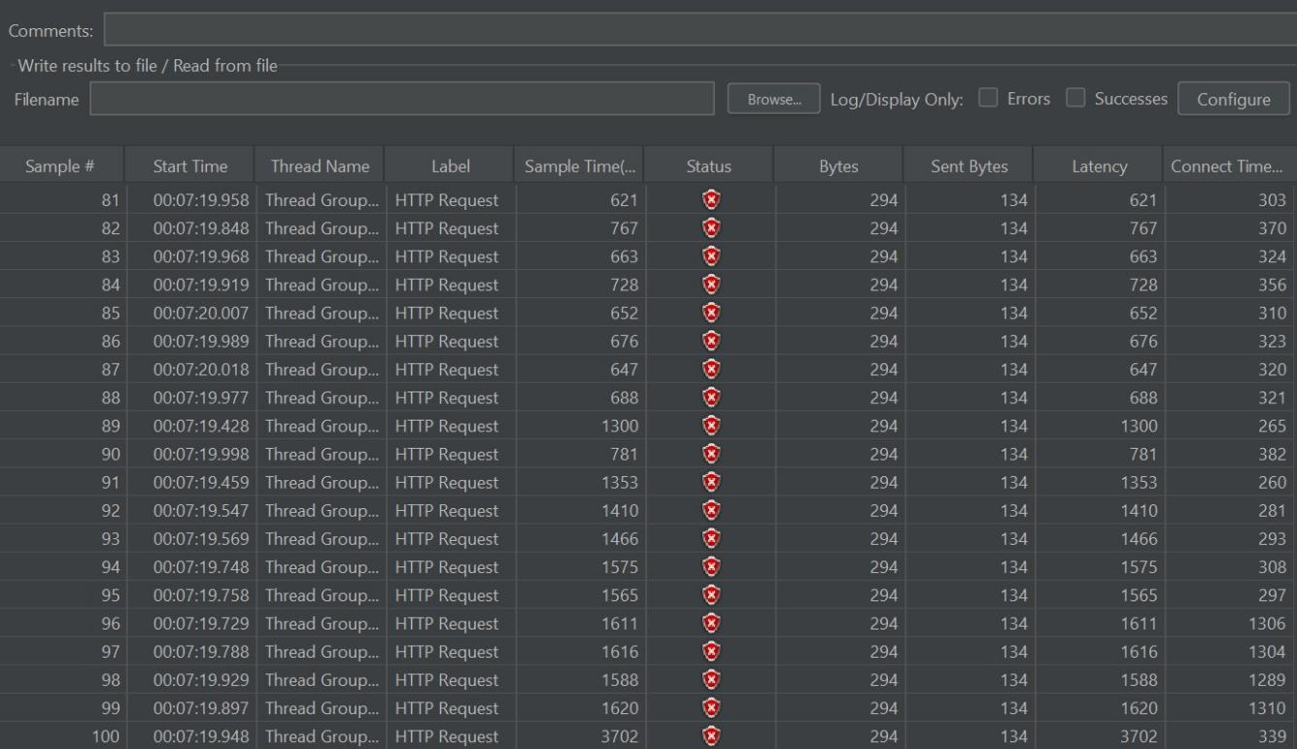

**Types of Performance Testing**: -

* Load Testing
* Stress Testing
* Volume Testing
* Soak/Endurance Testing

**Load Testing**: -

Testing stability and response time of application by applying load less than or equal to designed number of users.

**Stress Testing**: -

Testing stability and response time of application by applying load more than designed number of users.

**Volume Testing**: -

Testing stability and response time of application by transforming huge volume of data.

**Soak Testing**: -

Testing Stability and response time of application by applying load continuously for particular period of time.

* For what kind of application we do performance Testing.
* Any application which is used by multiple users.
* Any application which generates lots of revenue.

**TEST CASE**

Login Page :

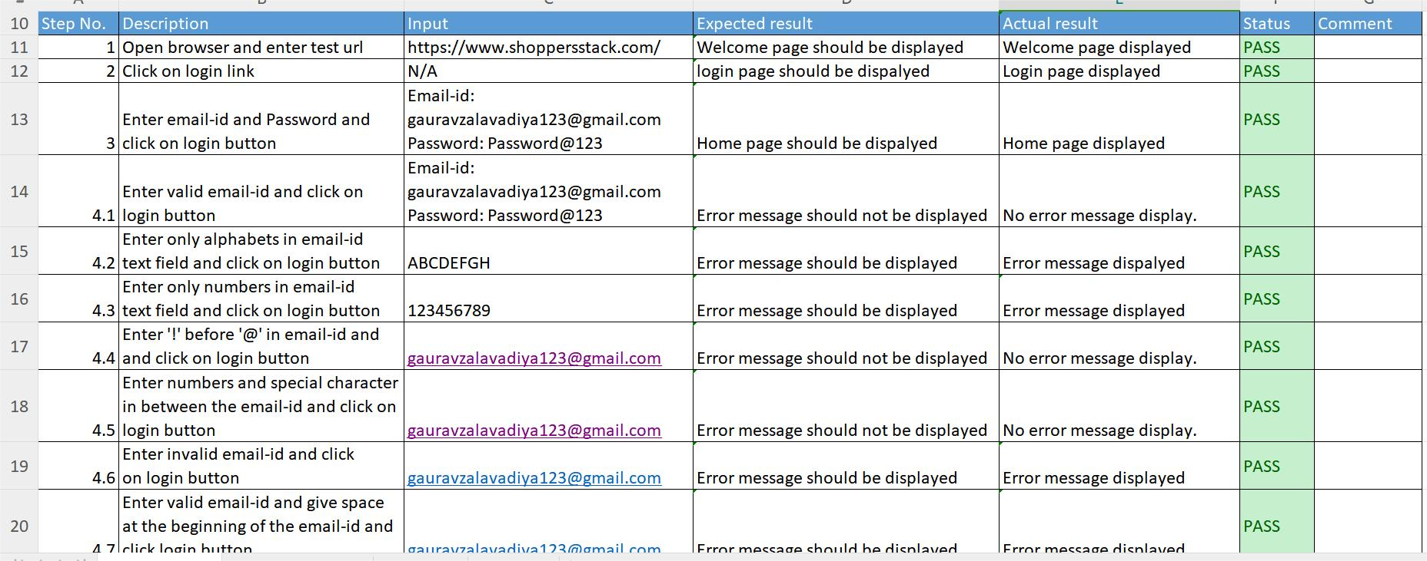

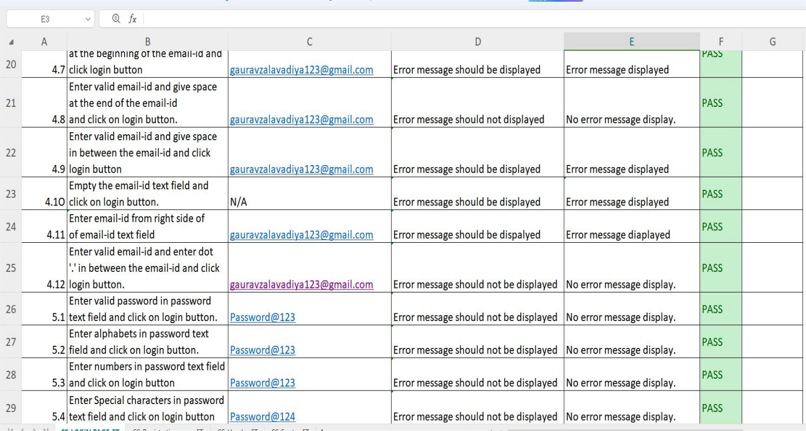

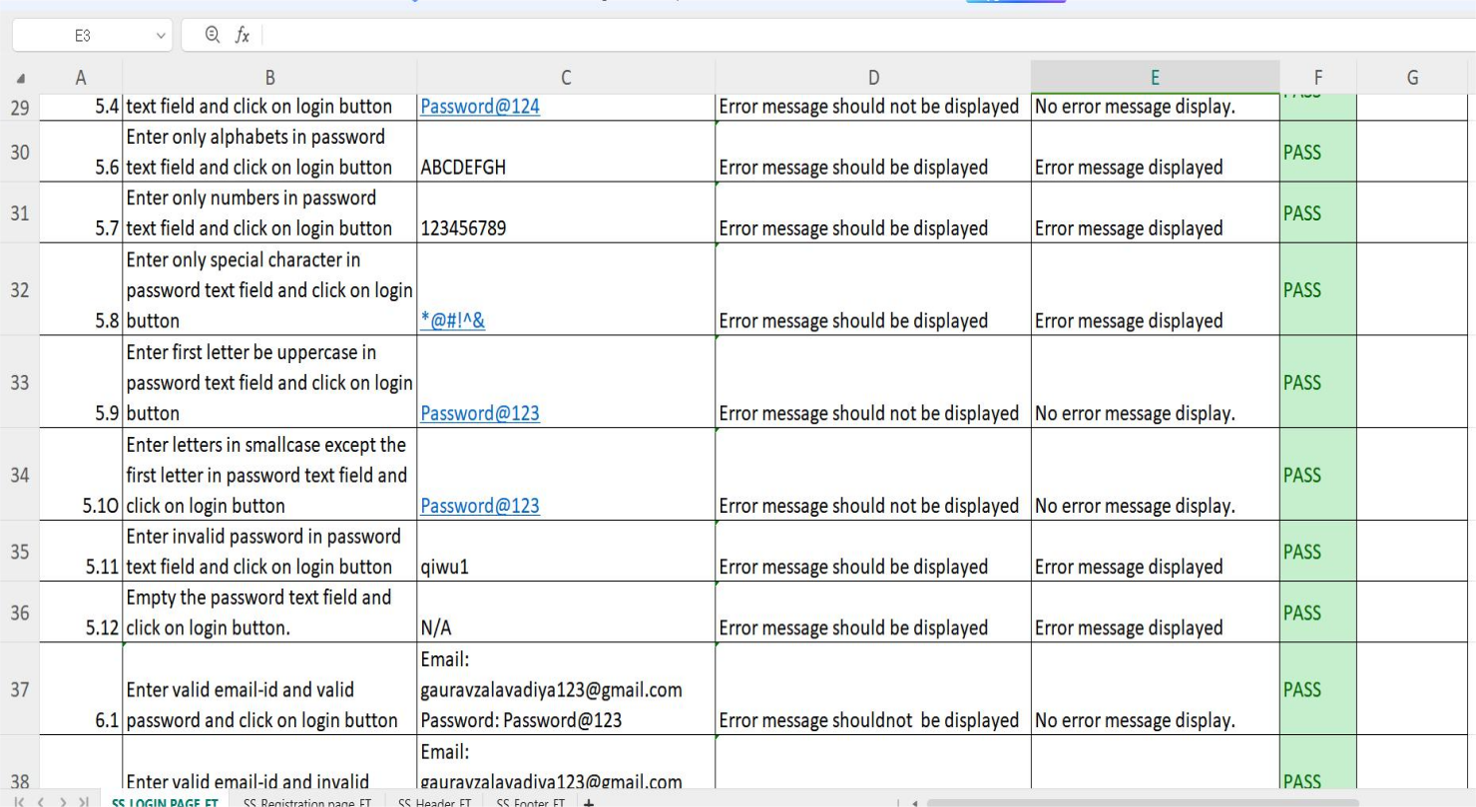

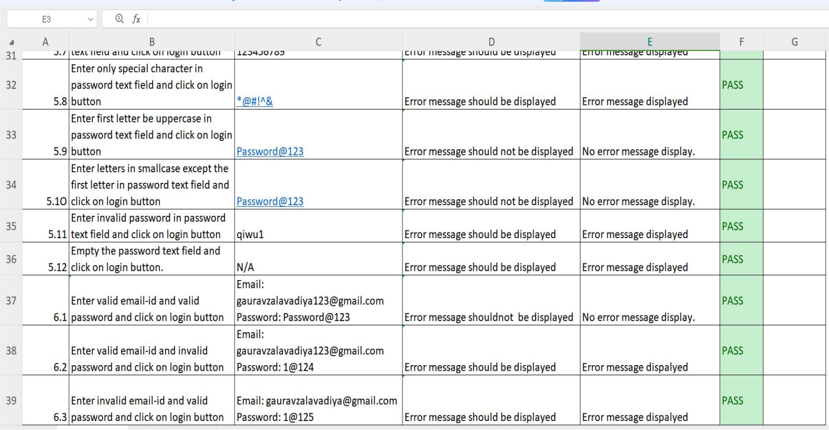

Registration page :

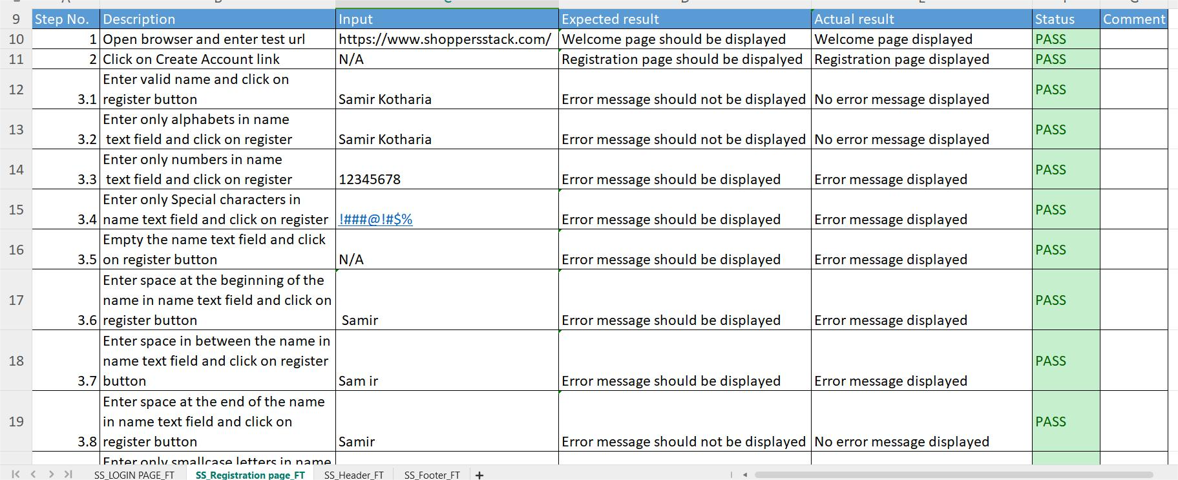

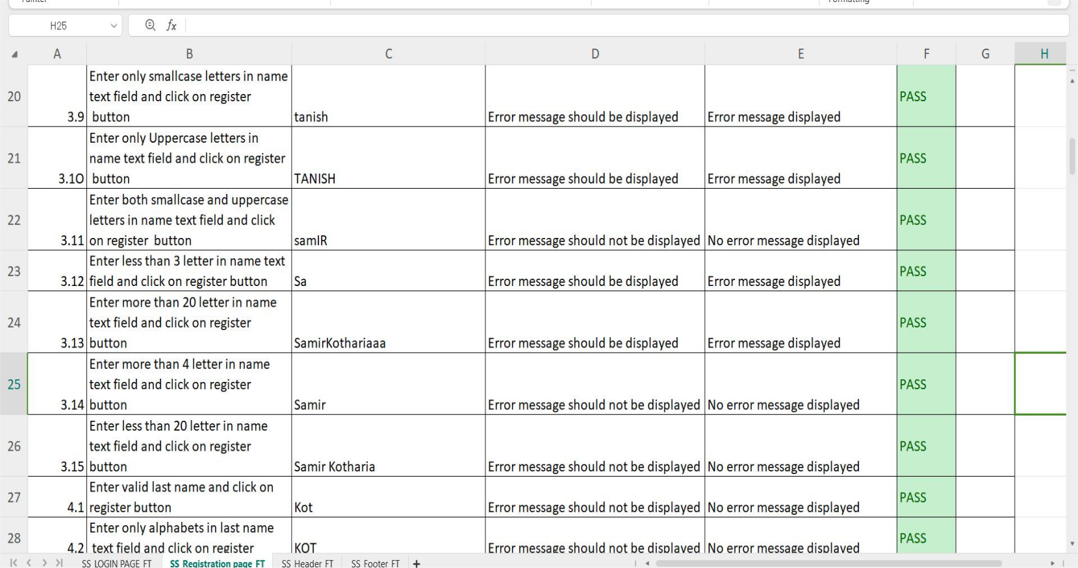

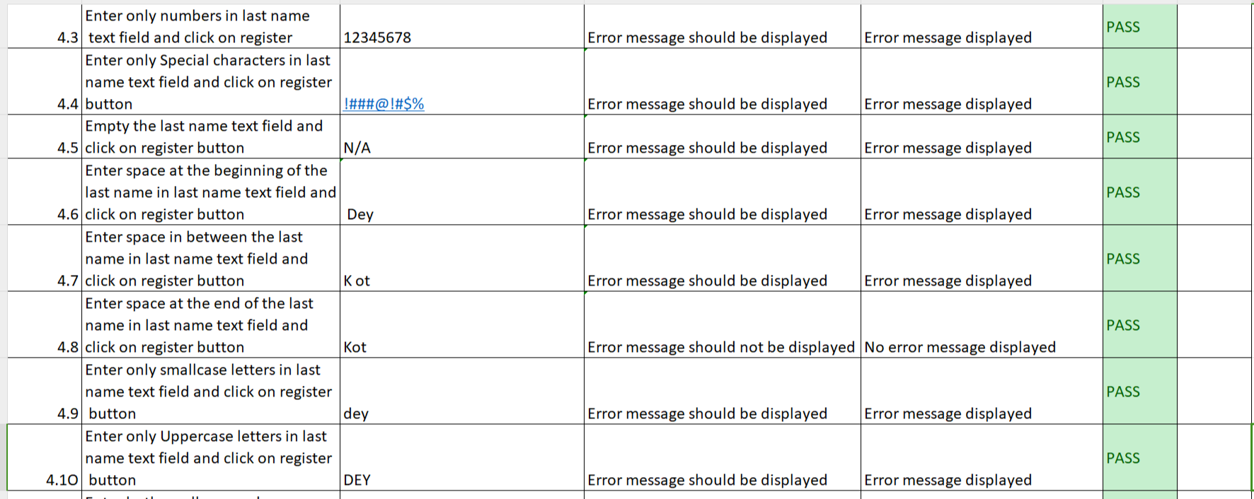

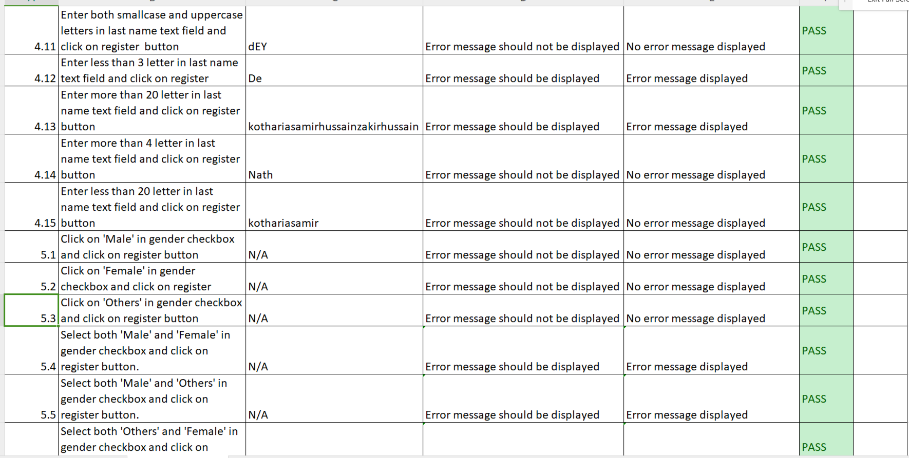

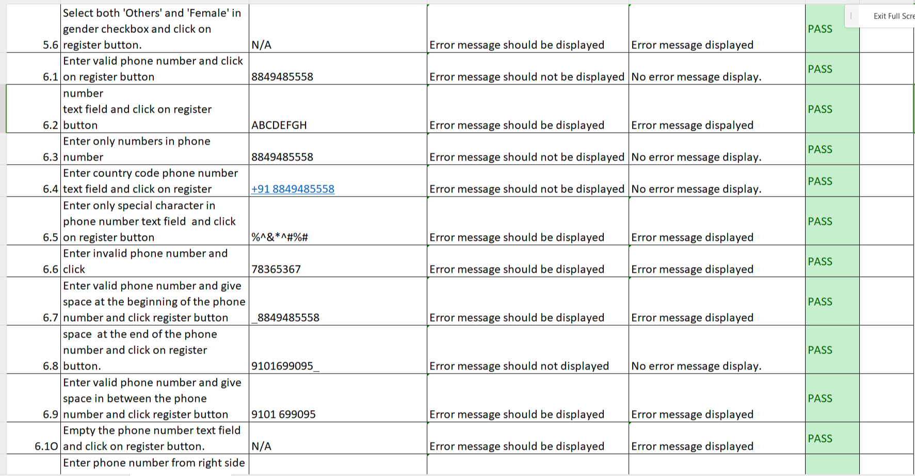

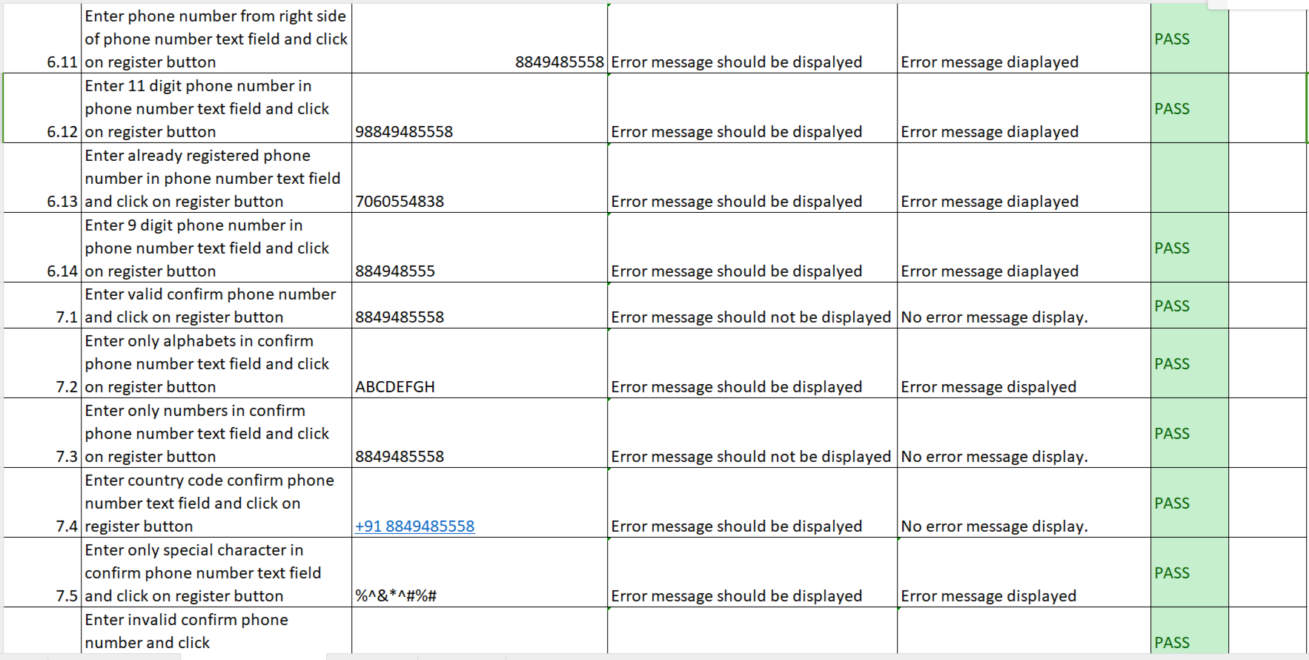

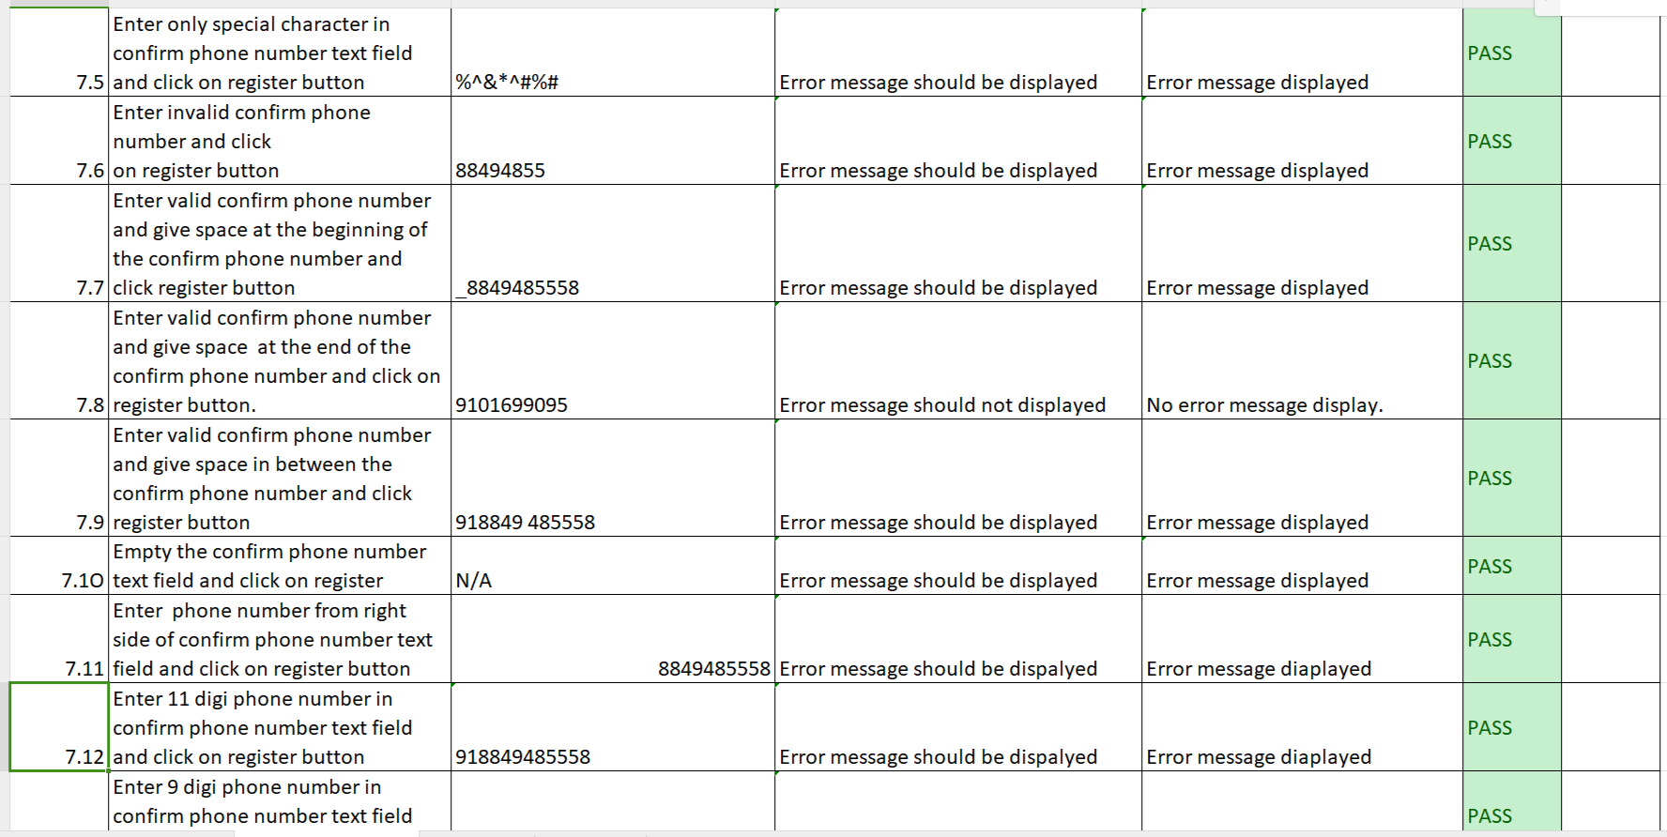

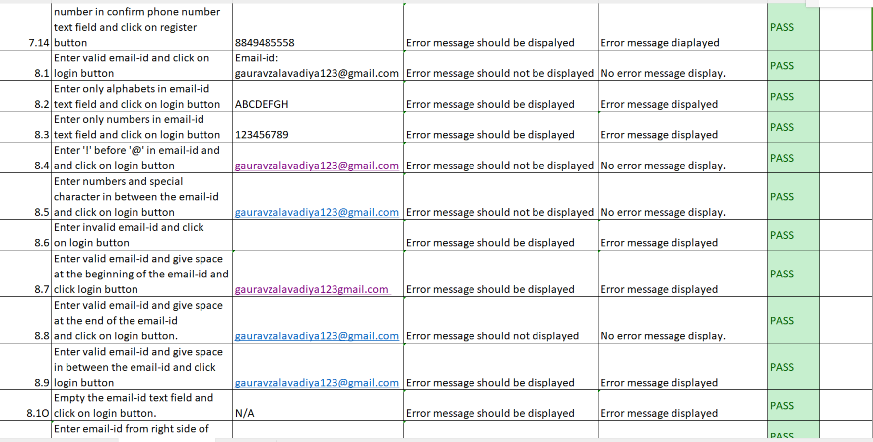

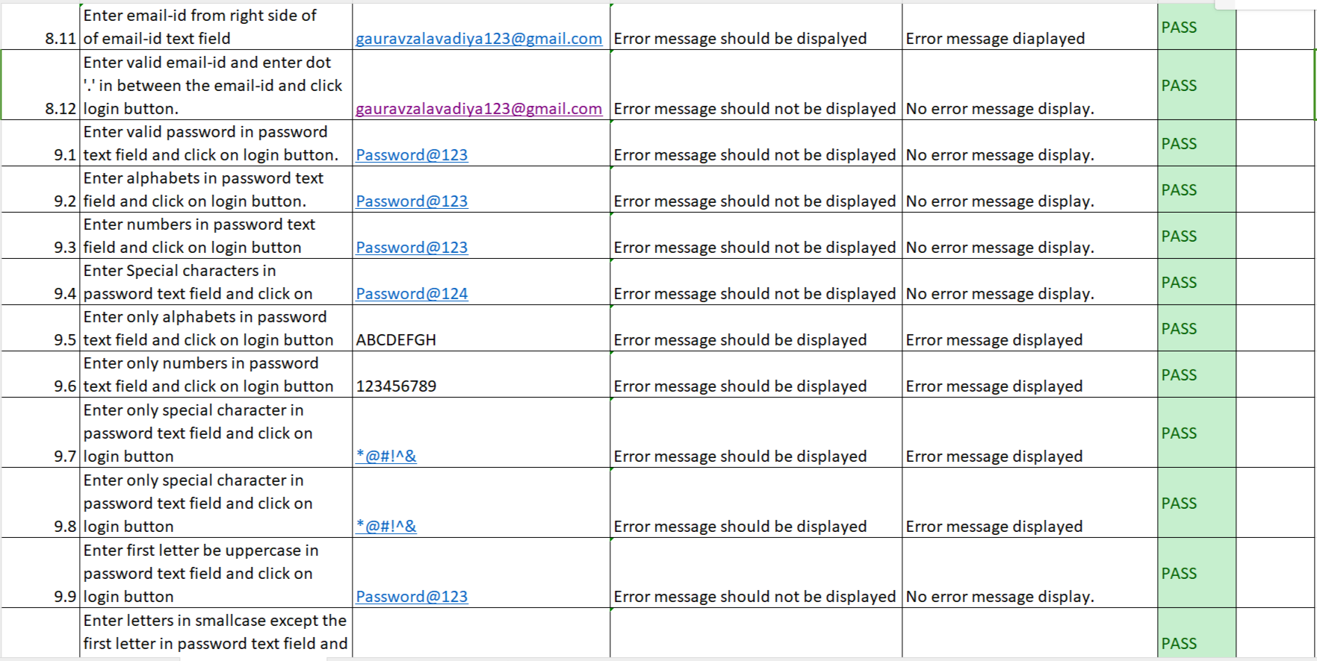

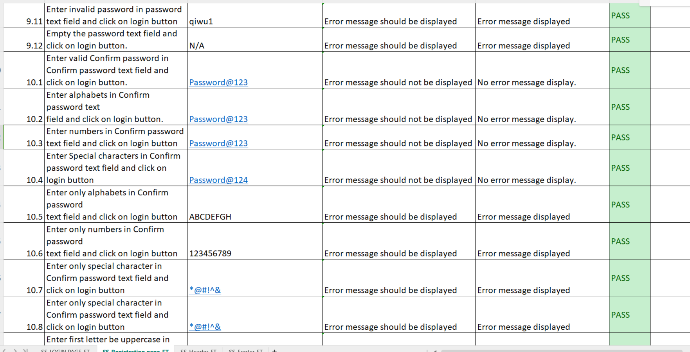

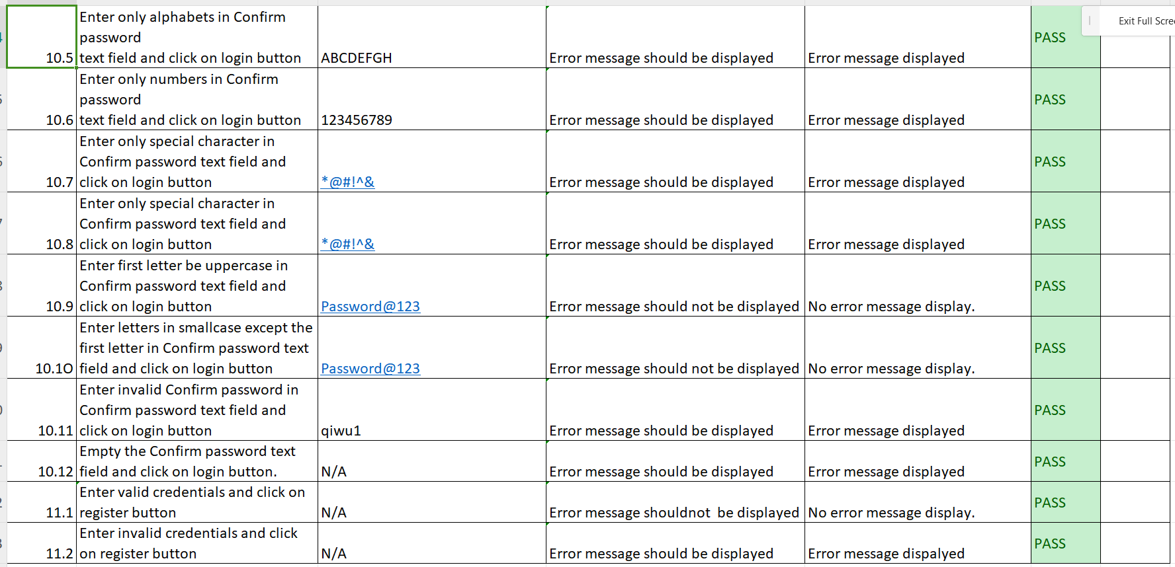

Main menu :

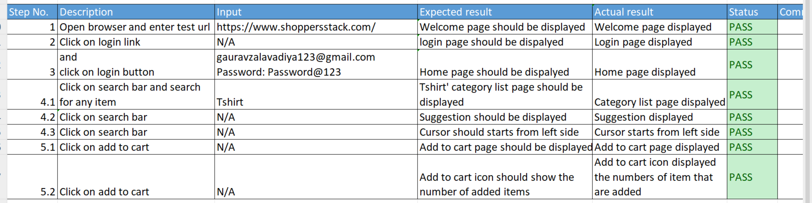

Footer Section :

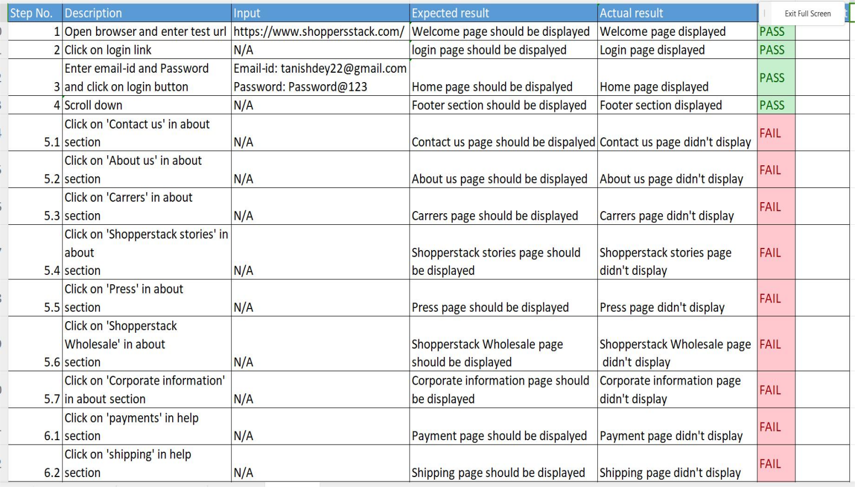

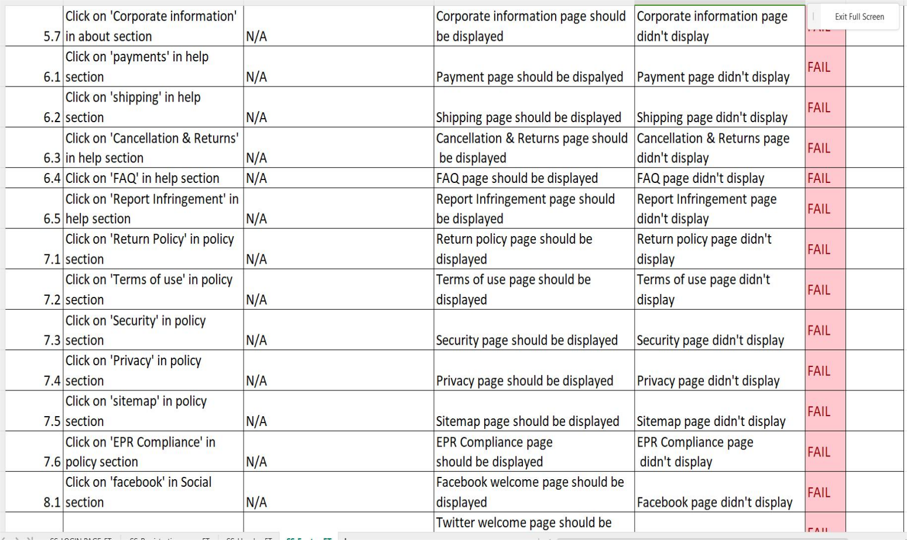

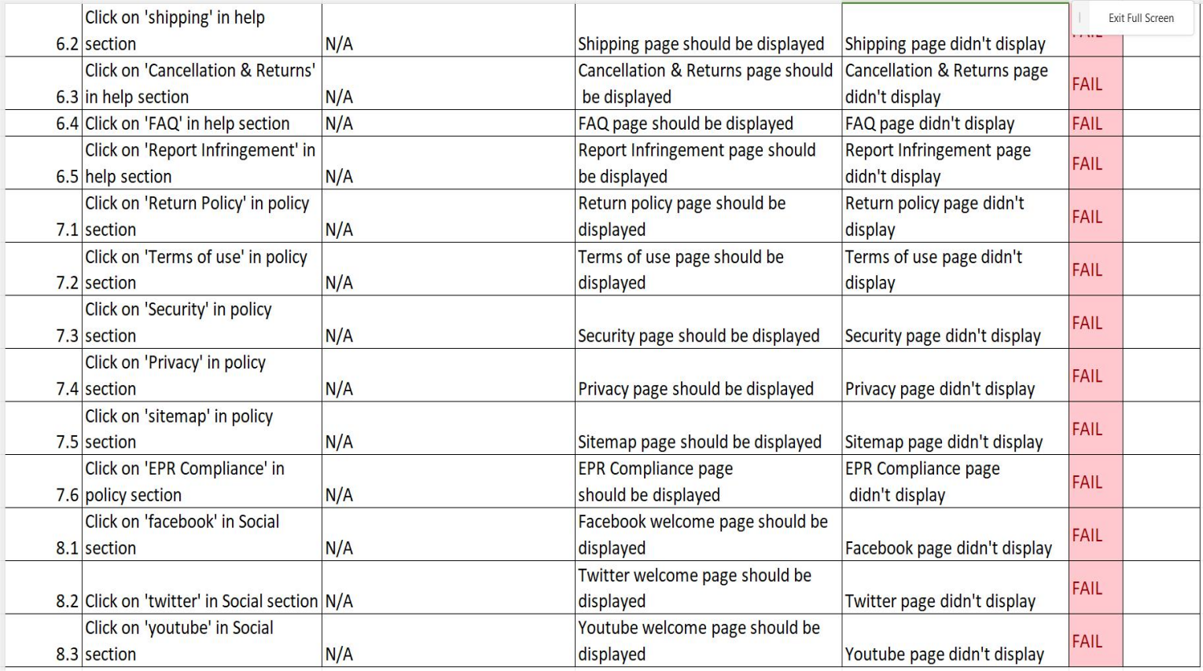

**AI AUTOMATION SCRIPTING**

We use Fireflink for AI automation scripting.

Fireflink Platform, a high-speed test automation platform, is the future of agile software testing.

It is a revolutionary advancement in the testing industry because it is a script less, end-to-end test automation platform for Web, Android, iOS, and API tests.

Fireflink is an automation AI Scripting tool for testing a particular web application or software according to customer requirement specification.

There are main basis of repository, test development and test execution in Fireflink scripting tool.

There are main 2 component in Fireflink :

1. Repository: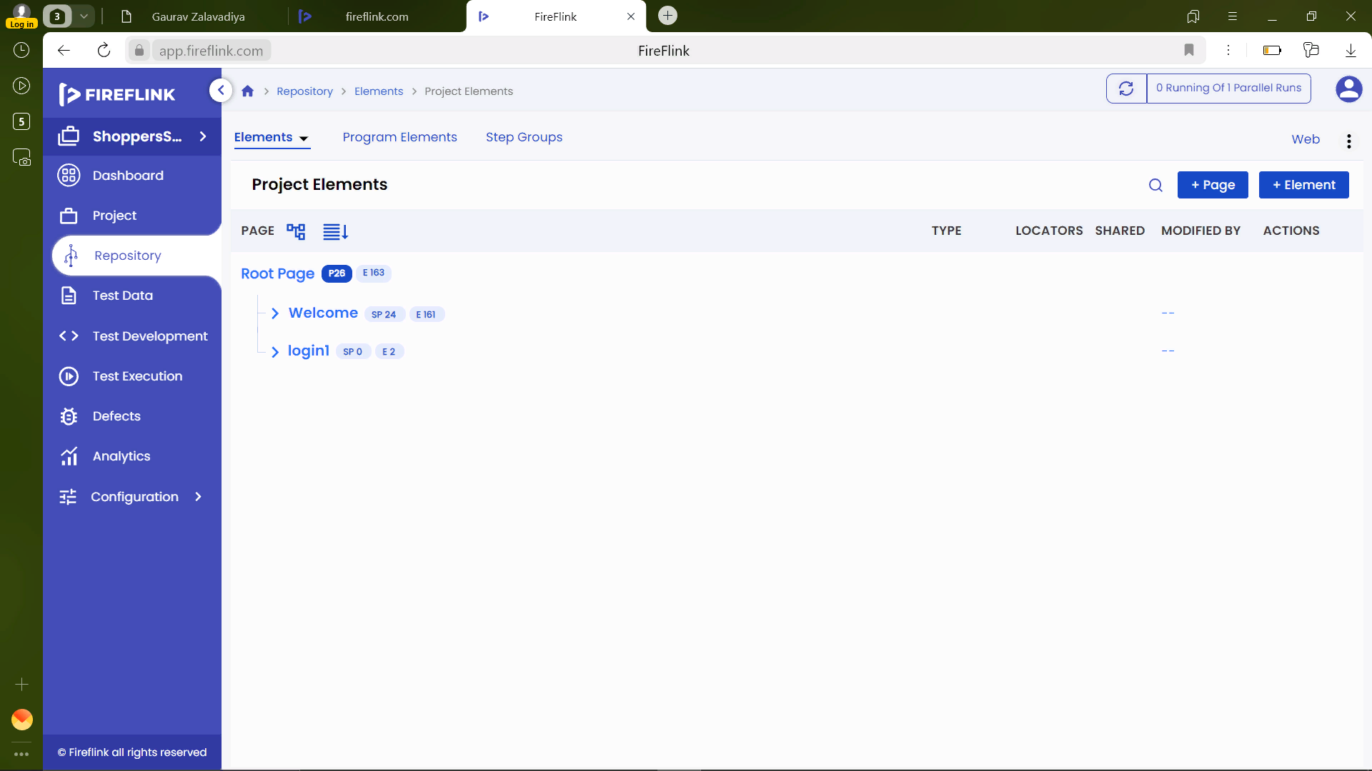

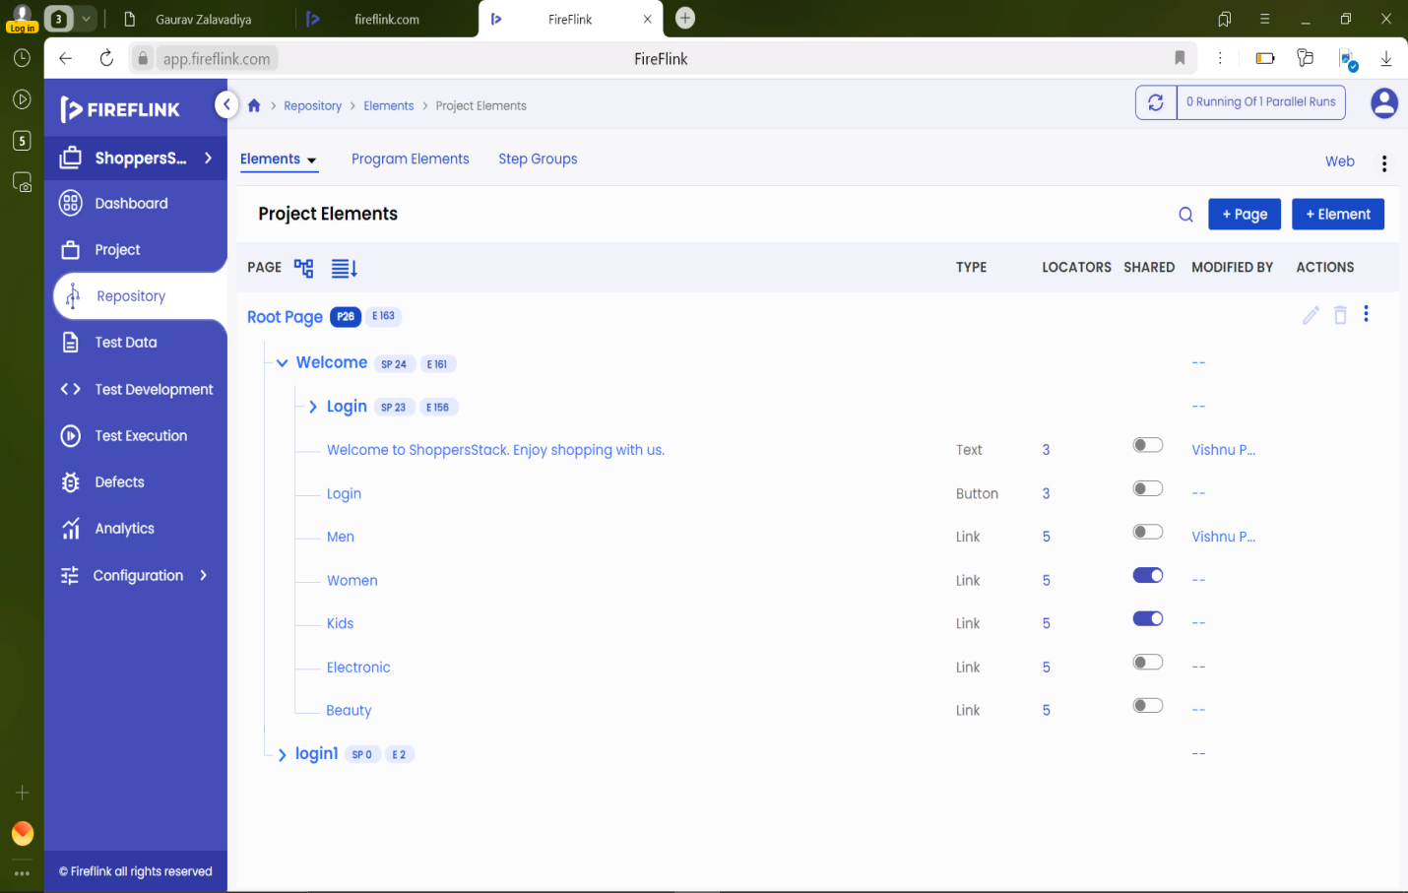

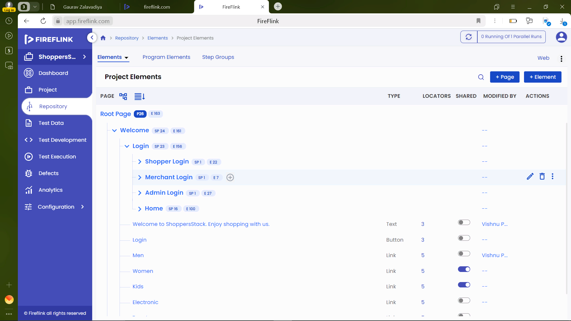

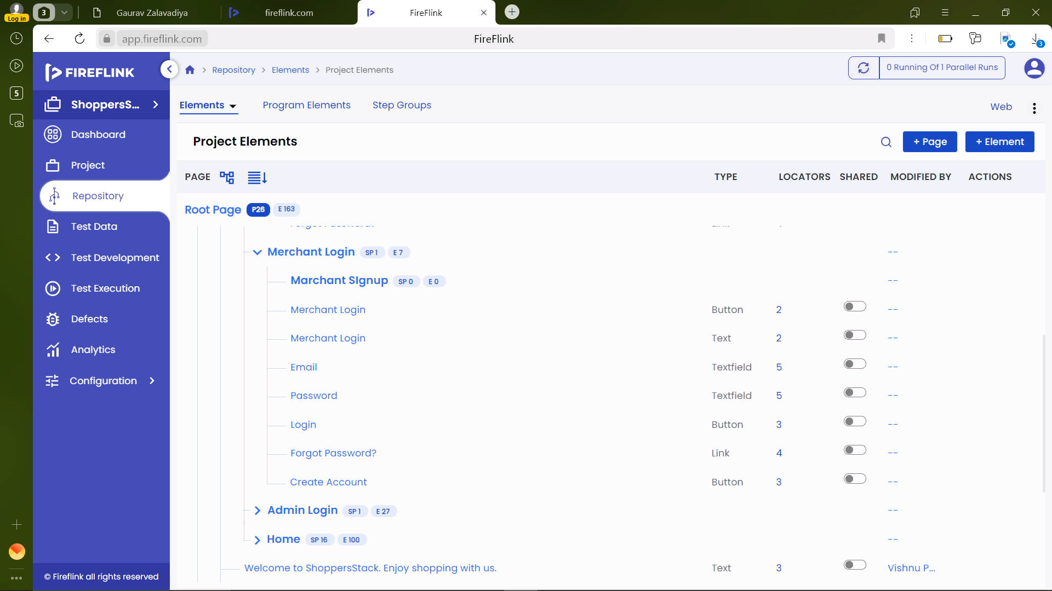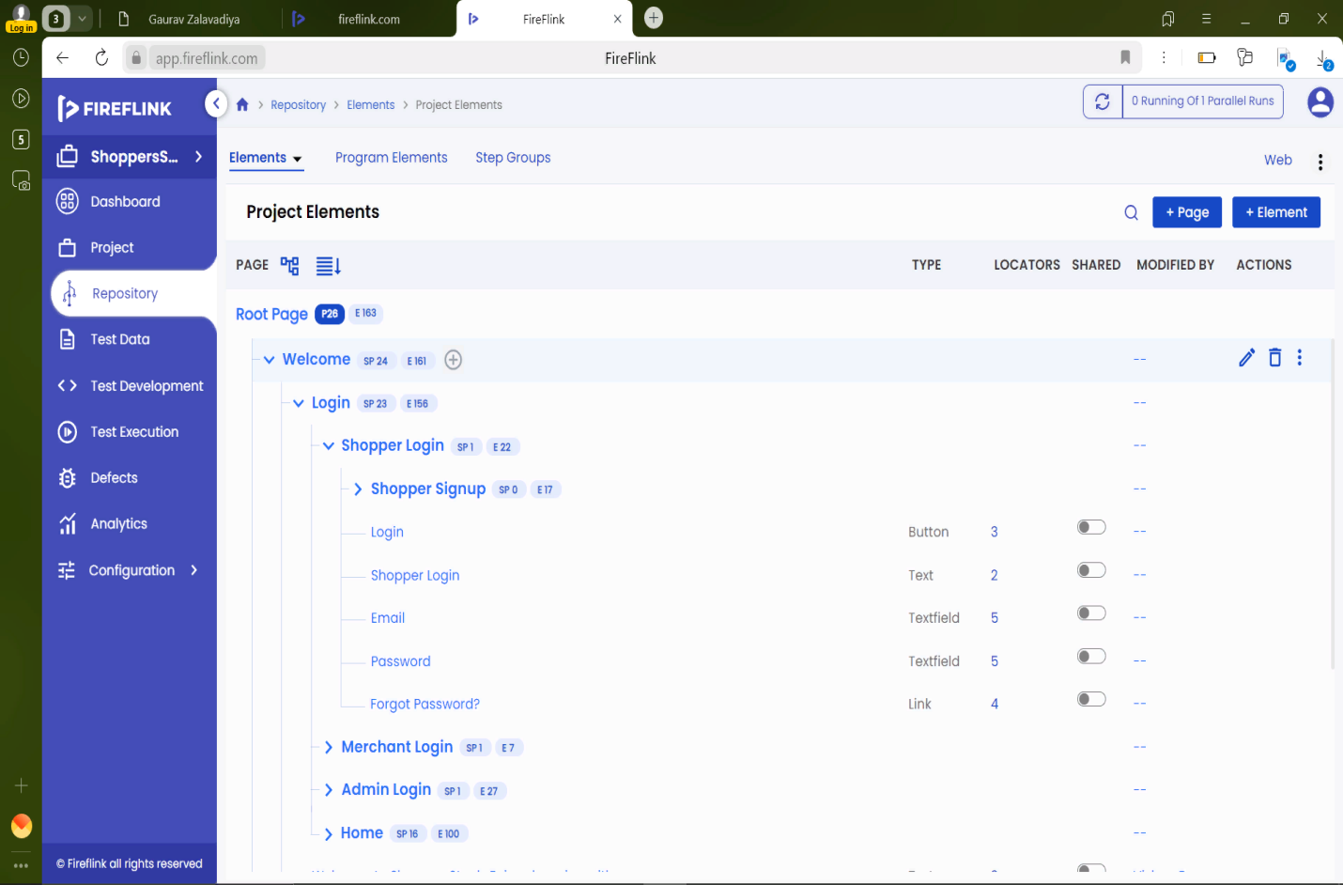

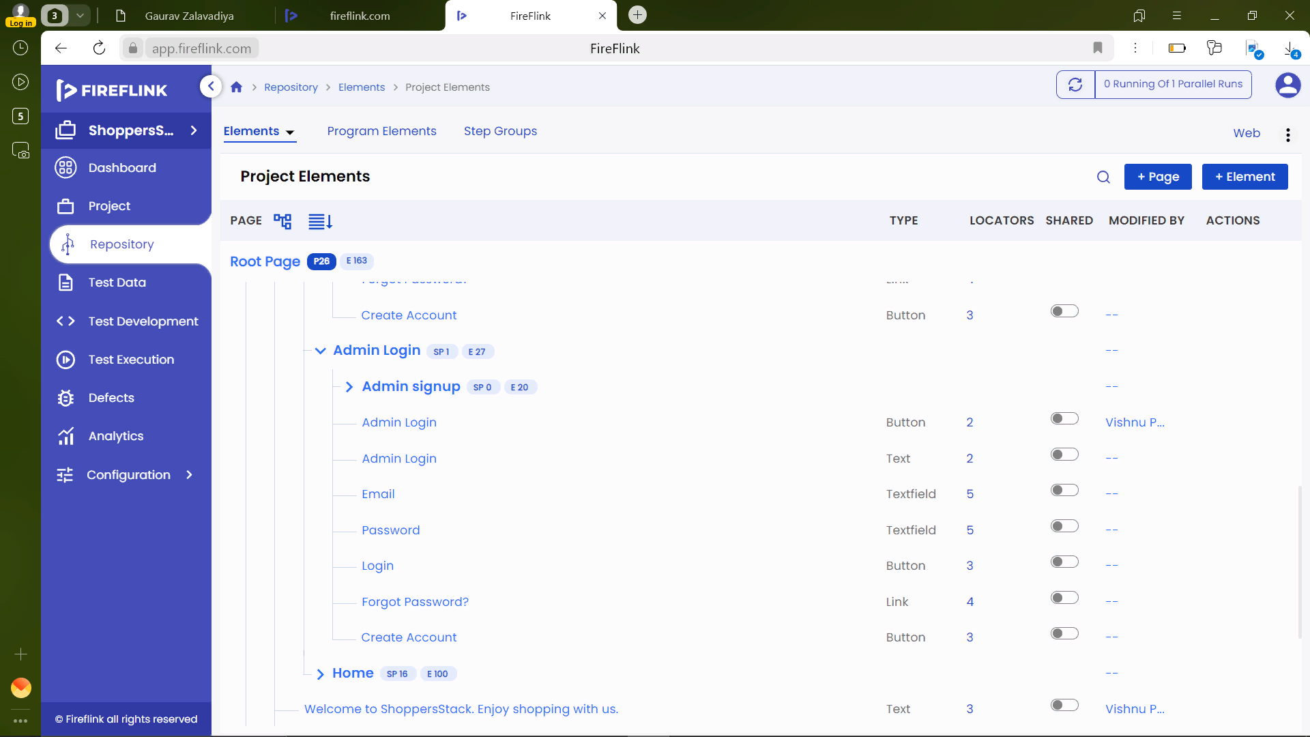

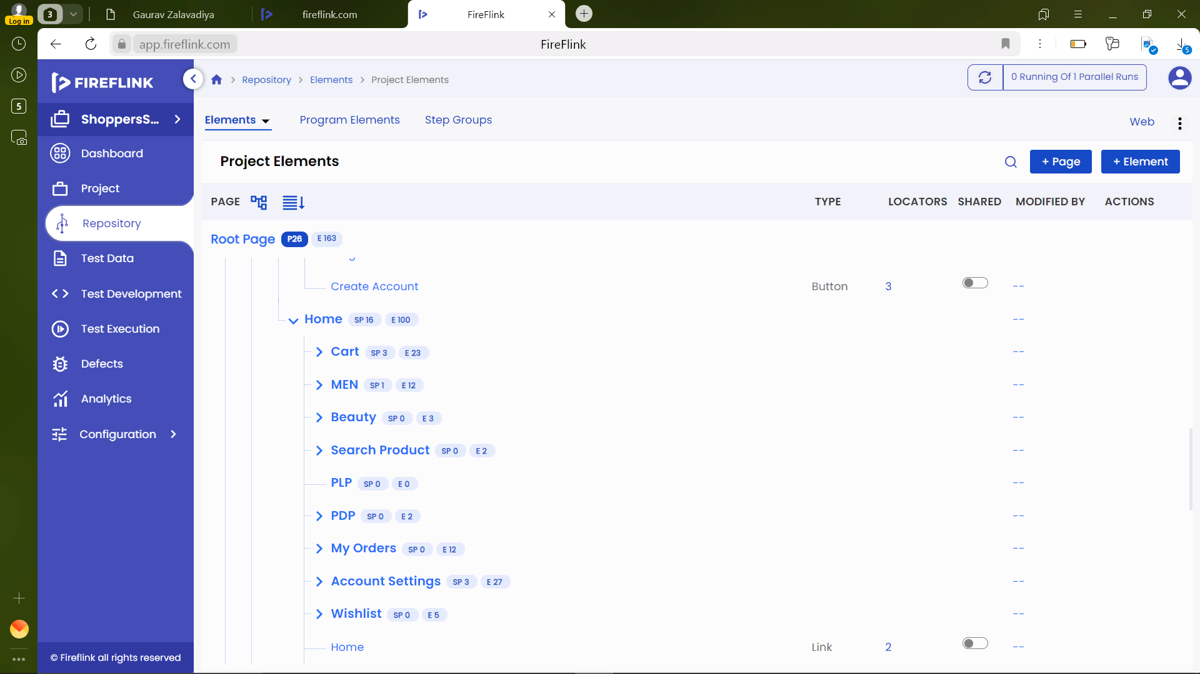

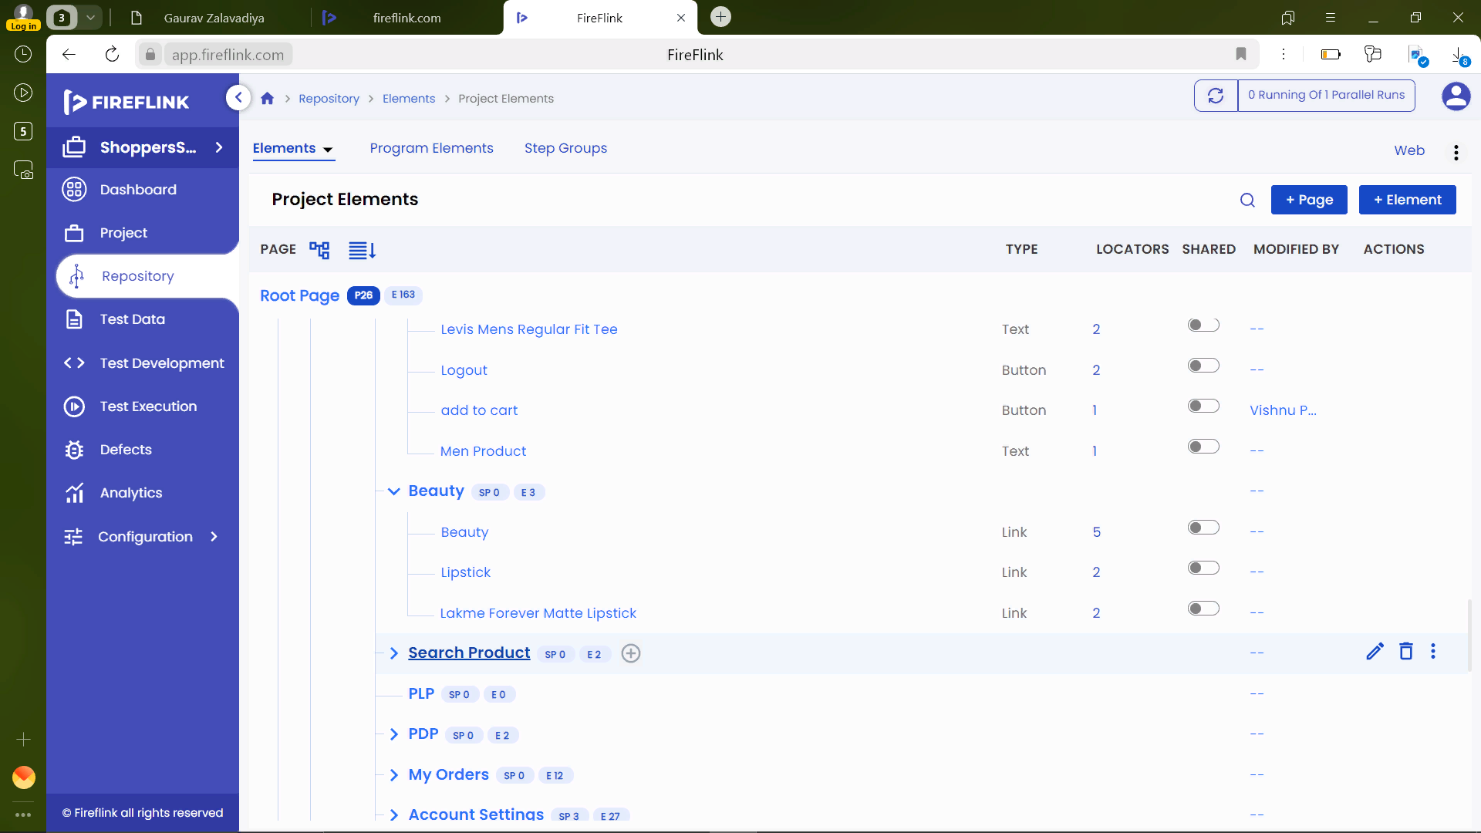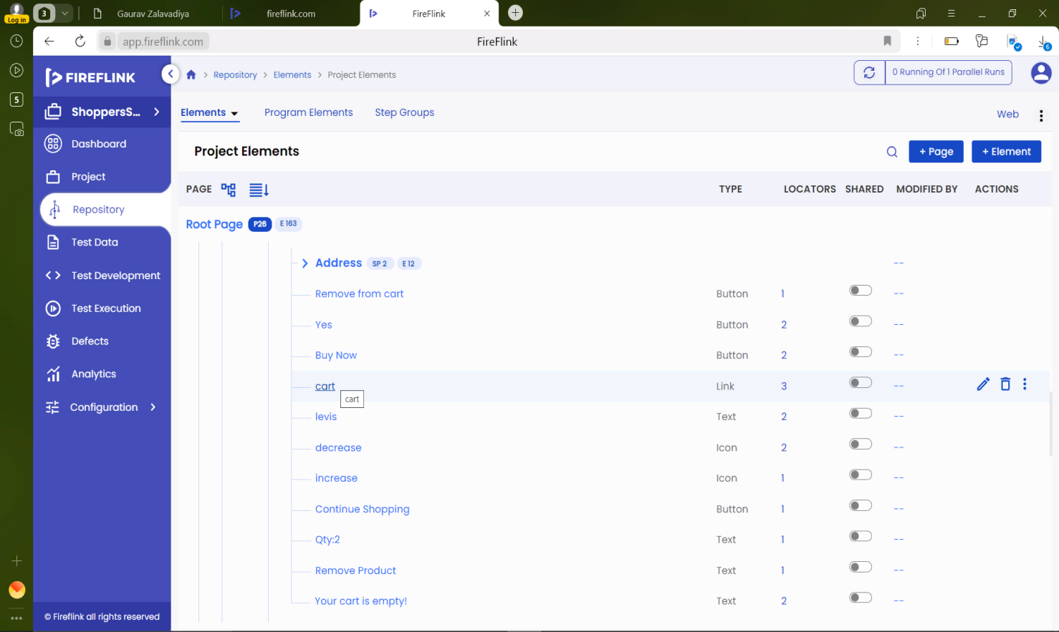

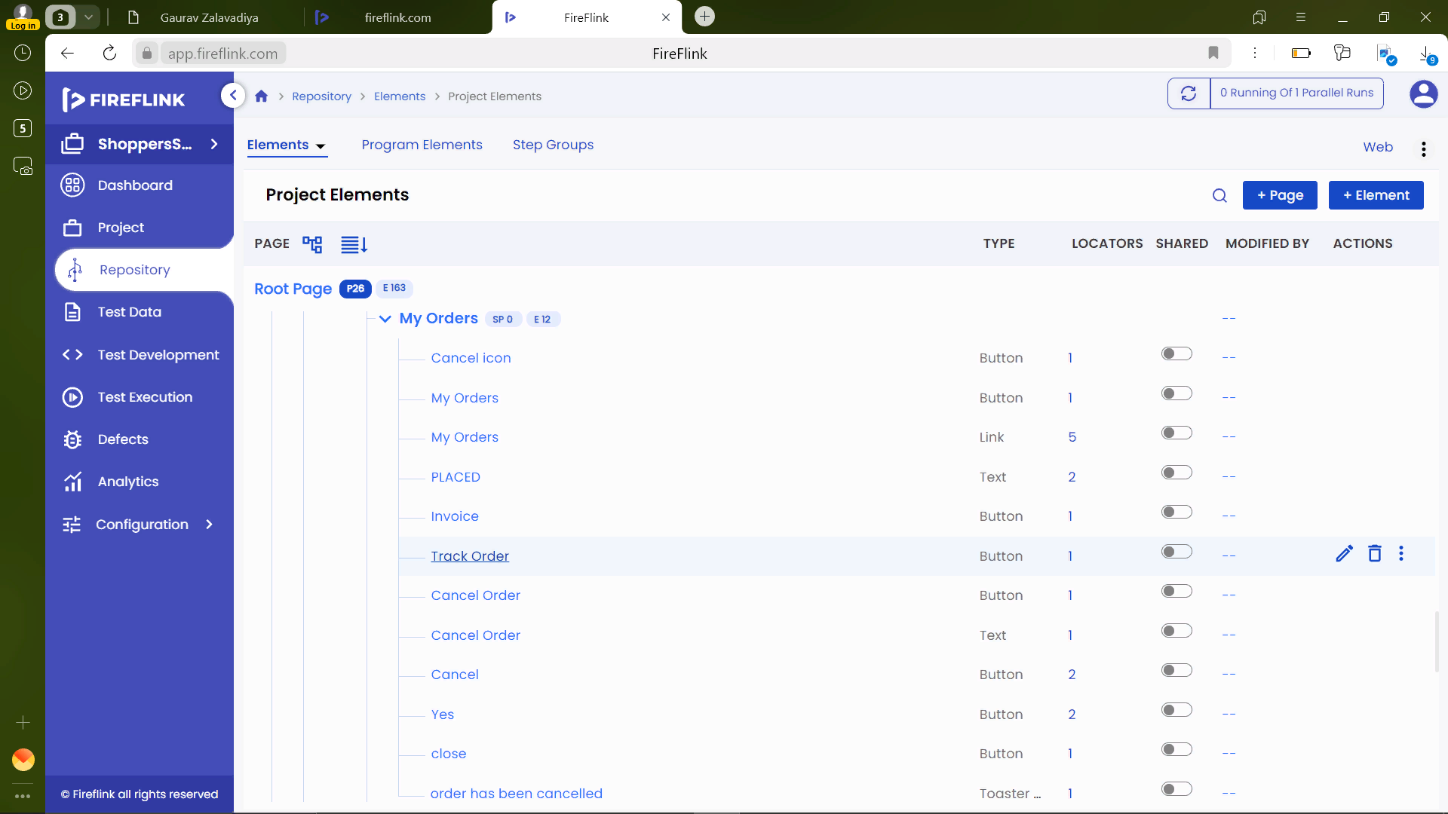

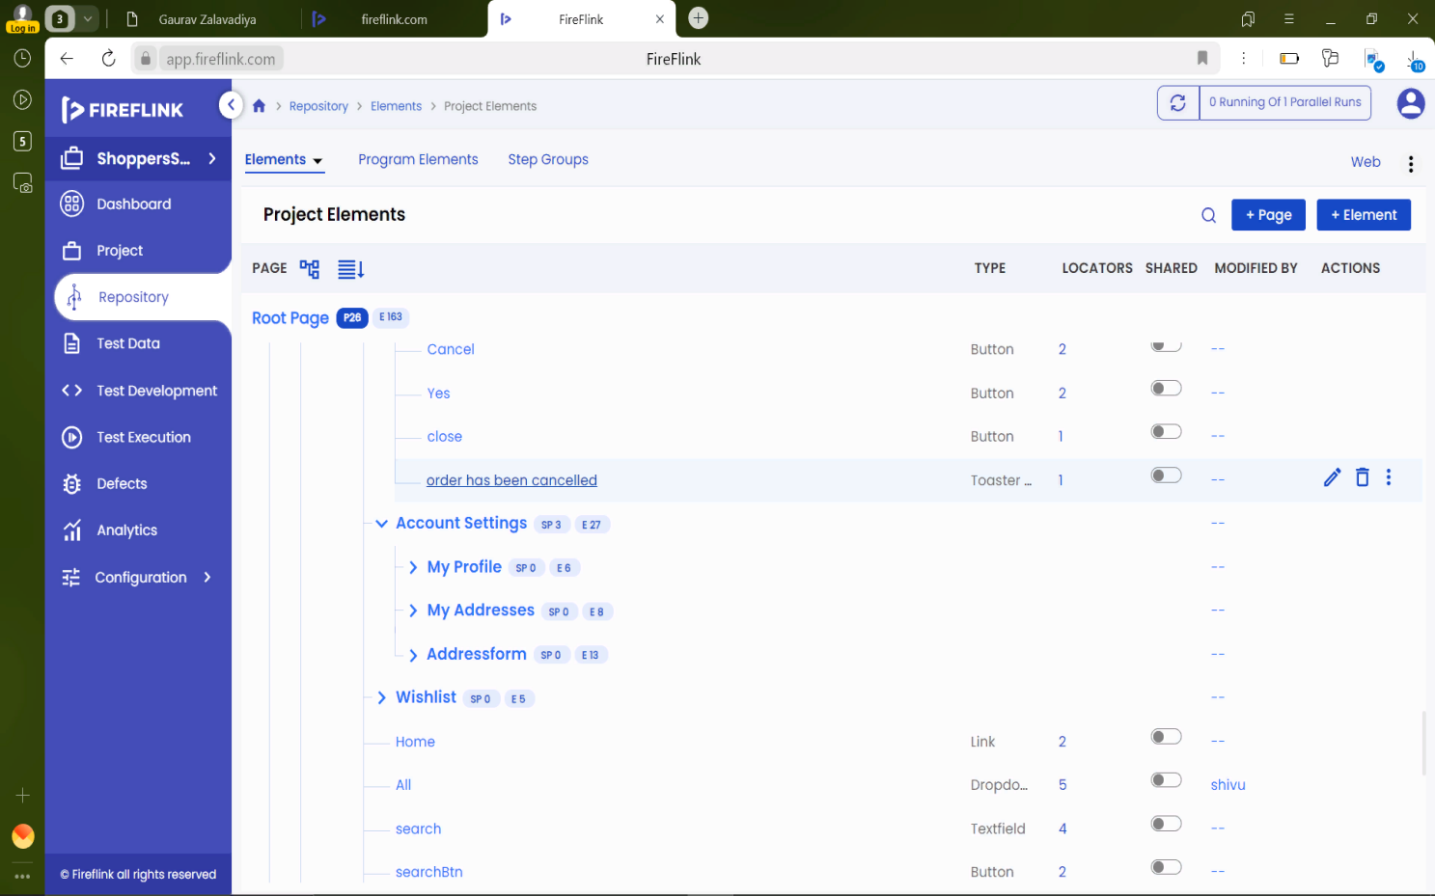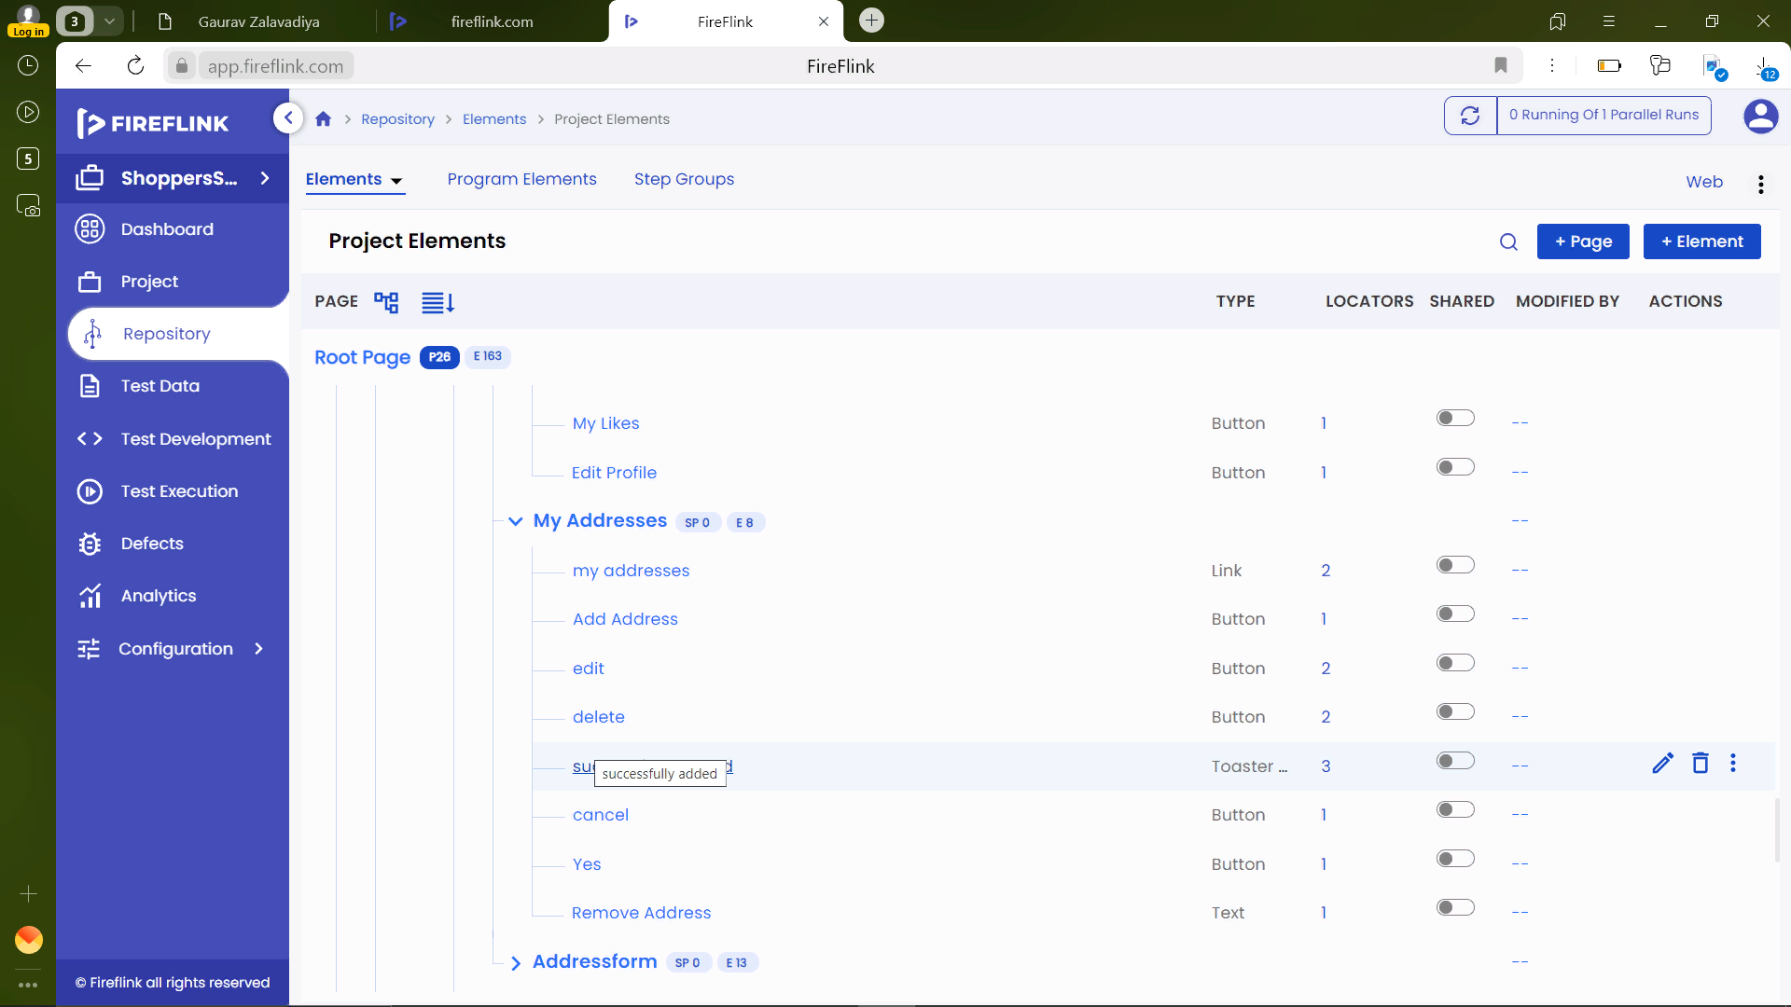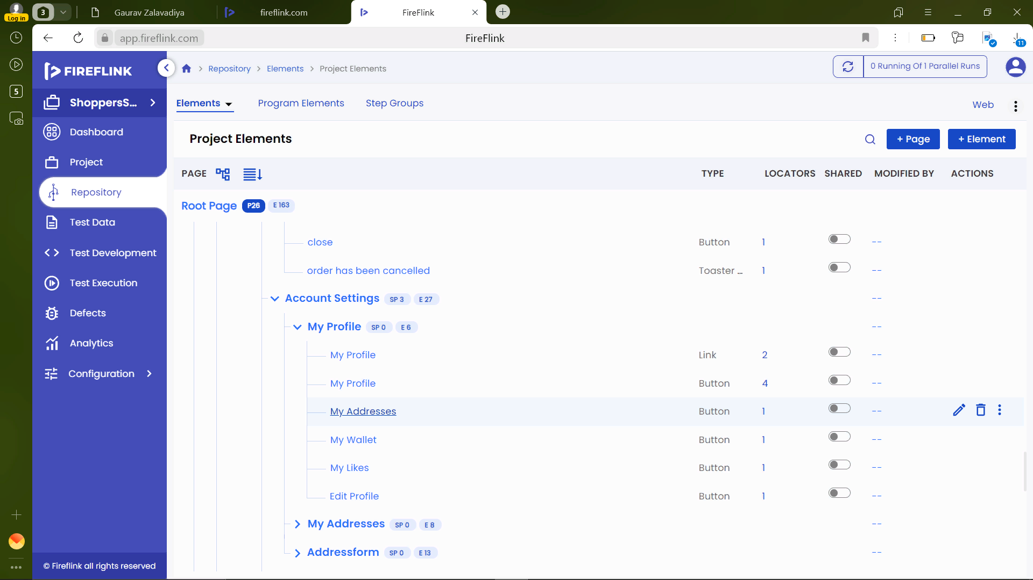

1. Test Development :

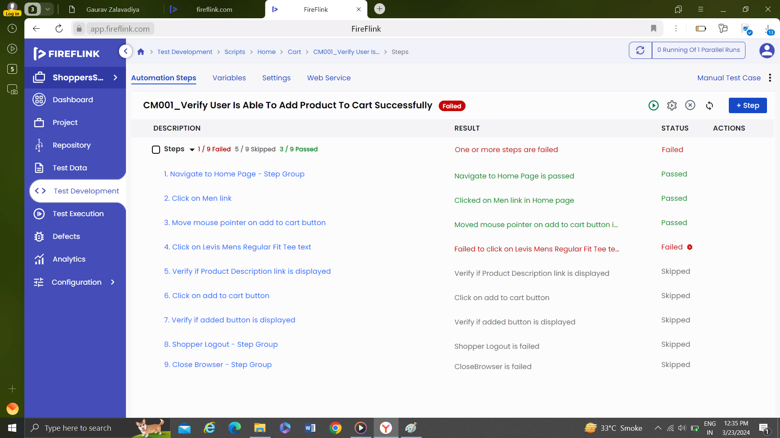

**FUTURE ENHANCEMENT**

When considering future enhancements for an Shopperstack in testing, it's essential to focus on improving user experience, increasing efficiency, and staying ahead of emerging trends. Here are some potential areas for future enhancement:

1. Personalization and Recommendation Engines
2. Augmented Reality (AR) and Virtual Try-On
3. Voice Commerce
4. Social Commerce Integration
5. Subscription Services
6. Dynamic Pricing and Offers
7. Mobile Wallet Integration
8. Progressive Web Applications (PWAs)
9. Chat bots and Virtual Assistants
10. Block chain Technology
11. Voice Commerce
12. Social Commerce Integration
13. Subscription Services
14. Dynamic Pricing and Offers
15. Augmented Reality (AR) and Virtual Try-On